# Setting Up the Lab Environment

**Setup Time**: 2 hours 30 minutes

**Overview**: Before you can begin to work on the lab exercises for this training course, you must first create a new virtual machine (VM) and install all the prerequisite software by following the instructions provided in this document. You will create a new VM using Microsoft's Hyper-V environment and then you will install the Windows Server 2012 operating system onto a new server named **WingtipServer**. You will then create a new Active Directory domain named **wingtip.com** by promoting **WingtipServer** to be a domain controller. After that, you will install SQL Server 2012 with service pack 1. The final task in completing the setup of this VM will be to download the installation files for **SharePoint Server 2013** and **SharePoint Designer 2013**. Once you have completed all the tasks in this setup guide, you will have created a VM that can be used as the starting point for any of the SharePoint 2013 Administration courses offered by Critical Path Training.

The instructions to create a VM and the screenshots in this setup guide are based on Microsoft's Hyper-V Environment. If you plan to build the VM using a different virtualization product other than Hyper-V such as VMWare, you will have to make adjustments as you move through this setup guide for the ways in which your virtualization product differs from Hyper-V.

### Task 1: Make Sure You Meet the Hardware Requirements

Before getting started, make sure you have a student workstation that meets the following requirements

1. Make sure you have a host computer running either Windows 8, Windows Server 2012 or Windows Server 2008 R2.
2. Make sure your host computer is configured to run Hyper-V.
3. Make sure your host computer has at least 100GB of free hard drive space
4. Make sure your host computer has enough RAM to run a VM with SharePoint Server 2013
   1. 16GB is the recommended amount of RAM.
   2. 12GB should be considered the minimum amount of RAM to achieve acceptable performance.
   3. Running with less than 12GB of RAM of your host computer will likely lead to poor performance and is not recommended.
5. Make sure your host computer has a connection to the Internet.
   1. The connection can be based on either a network card with a cable plugged in or a wireless connection.

Note that the instructions and the screenshots of the host computer and the Hyper-V environment in this document were created using Windows 8. Things will look a bit different with Hyper-V if you are running Windows Server 2012 or Windows Server 2008 R2.

### Task 2: Configure the Hyper-V Network Adapters on the Host Computer

In this task you will configure two Hyper-V network adapters. This task involves creating two virtual switches in Hyper-V that will be used to configure both an internal network adapter and an external network adapter. The internal network adapter will be used to configure static IP address in the VM. The external network adapter will be used to connect the VM to the Internet.

1. Launch the Hyper-V Manager: **Start** 🡪 **Administrative Tools** 🡪 **Hyper-V Manager**.

The host computer that was used to create the following screenshots is named **HULLABALOO**. Your screen will look a little different because your host computer will have a different name.

1. Create a new virtual switch named **Internal** for an internal network adapter:
   1. In the **Actions** pane on the right-hand side of the screen, click **Virtual Switch Manager**.

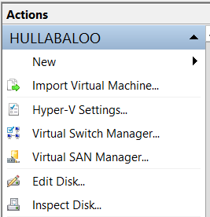

If you are using Windows Server 2008 R2, you are using an older version of Hyper-V which does not use the term **Virtual Switch**. This older version of Hyper-V uses the term **Virtual LAN** instead of **Virtual Switch** so the screenshots shown here will not match.

* 1. In the **Virtual Switch Manager** dialog, create a new virtual switch by selecting **Internal** and then clicking the **Create Virtual Switch** button.

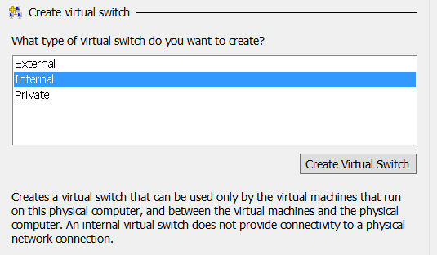

* 1. Configure the new virtual switch with the following properties:
     1. **Name**: Internal
     2. **Connection Type**: Internal network.

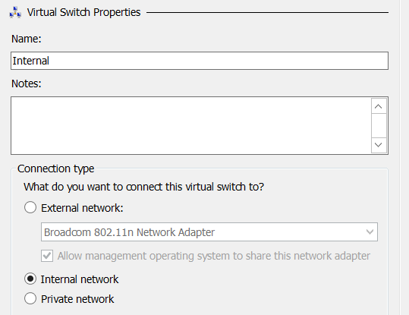

* 1. Click **OK** to save your changes.

In the next step you will create an external virtual switch that will be used to connect the VM to the Internet. You can create this external network switch by using either a network adapter with a network cabled plugged in or a wireless connection on your host computer. All that is required is that you create the virtual switch using a network adapter on your host computer that can connect to the Internet. The Internet connection is an essential part of the setup for this VM because it's required when running the Prerequisite Installer utility of SharePoint Server 2013.

1. Create a new virtual switch named **External** for an external network adapter:
   1. In the **Actions** pane on the right-hand side of the screen, click **Virtual Switch Manager**.



* 1. In the **Virtual Switch Manager** dialog, create a new virtual switch by selecting **External** and then clicking the **Create Virtual Switch** button.

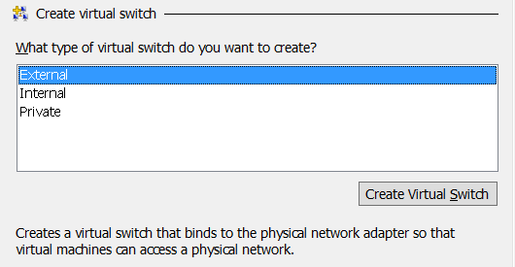

* 1. Configure the new virtual switch with the following properties:
     1. **Name**: External
     2. **Connection Type**: External network.
        1. Make sure to select a network adapter or wireless connection from the host computer in the dropdown menu under the **External network** radio button.

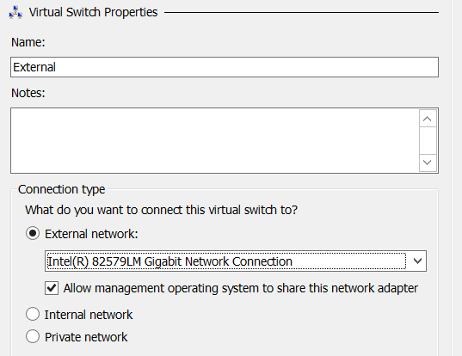

* 1. Click **OK** to save your changes.

### Task 3: Create a new Virtual Machine (VM) using Hyper-V

To complete this task you will create a new VM using the Hyper-V environment.

1. If it is not open, launch **Hyper-V Manager**.
2. On the left-hand side of **Hyper-V Manager**, locate the node with the name of the local host computer and select it.
3. In the **Actions** pane select **New 🡪 Virtual Machine**.
   1. When you execute this menu command, the Hyper-V Manager will launch the **New Virtual Machine Wizard**.

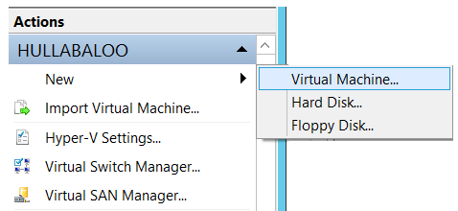

1. The **New Virtual Machine Wizard** begins with the **Specify Name and location dialog.**
   1. Enter a **Name** of **WingtipServer**.
   2. Select a folder path for the **Location** property where the virtual machine files will be stored. Ensure the **Location** path is hosted by a hard drive that has at least 100GB of free space. If possible, configure the **Location** path on a secondary hard drive that is different from the hard drive running the host operating system to improve the performance of your VM.

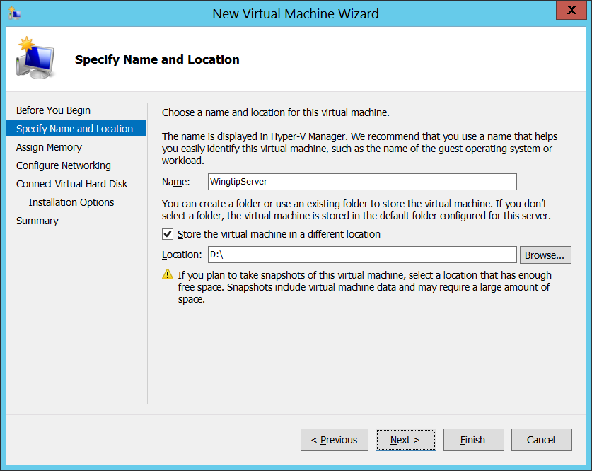

* 1. Click **Next.**

1. In the **Assign Memory** dialog, enter the amount of **Memory** to allocate to the virtual machine.
   1. Determine the amount of memory to use for the VM from the following table.

|  |  |
| --- | --- |
| **If host machine has this much RAM** | **Then configure the VM with this much RAM** |
| 16 GB or more | 14 GB - configure the VM with **14336 MB** of RAM. |
| 14 GB | 12 GB - configure the VM with **12288 MB** of RAM. |
| 12 GB | 10 GB - configure the VM with **10240 MB** of RAM. |
| 10 GB (not supported) | 8 GB - configure the VM with **8192 MB** of RAM. |
| 8 GB (not supported) | 6.5 GB - configure the VM with **6656 MB** of RAM. |

* 1. Enter the amount of RAM you calculated in the previous step as the **Startup** memory property. Make sure you enter the number in megabytes (e.g. **14336 MB**). Finally, make sure to leave the **Use Dynamic Memory for this virtual machine** checkbox unchecked. Click **Next** to continue.

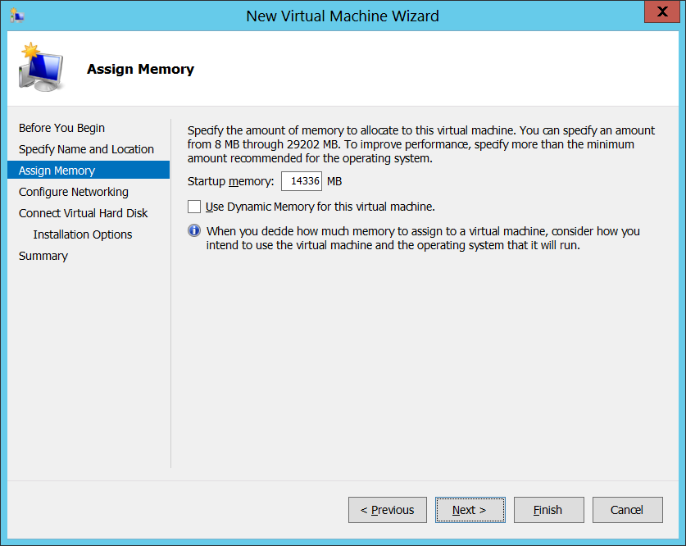

1. In the **Configure Networking** dialog, assign a **Connection** property of the **Internal** and click **Next**.

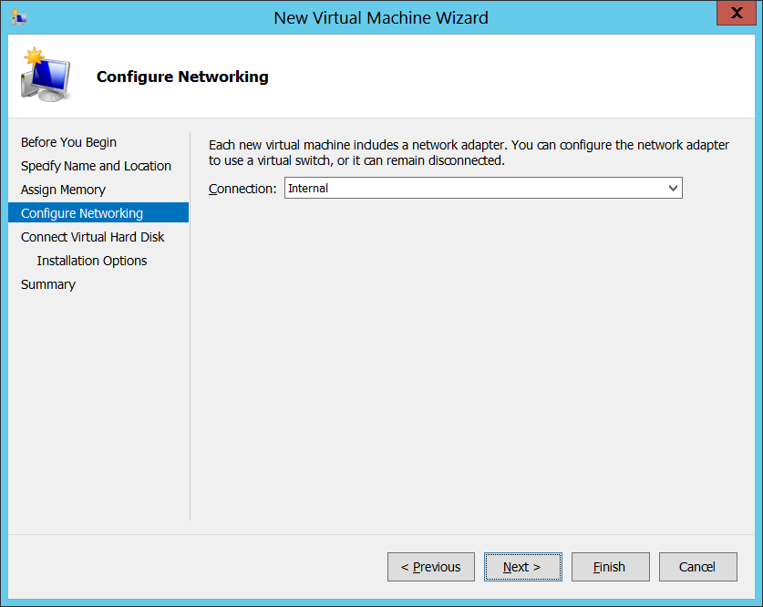

In the next step you will configure the file location for the files Hyper-V uses to store the VM. If possible, configure the VM file location on a separate physical drive that is different than the drive which holds the host computer’s operating system. This is one of the best way to increase the performance of a VM.

1. In the **Connect Virtual Hard Disk** dialog, accept the default option of **Create a virtual hard disk**. Make sure the **Location** is set to a directory in a local hard drive on our host computer that has at least 100 GB of free space. Click **Next**.

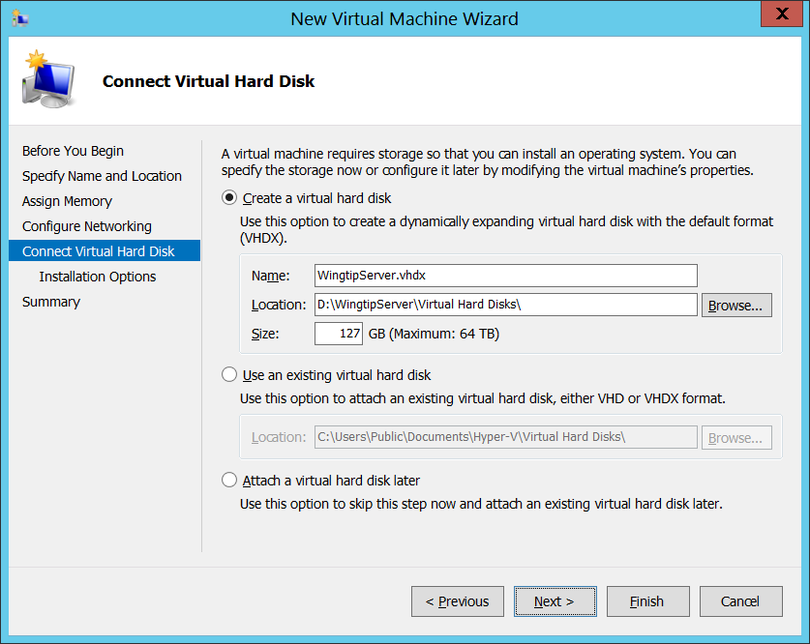

1. In the **Installation Options** dialog, accept the default option which is **Install an operating system later** and click **Next**.

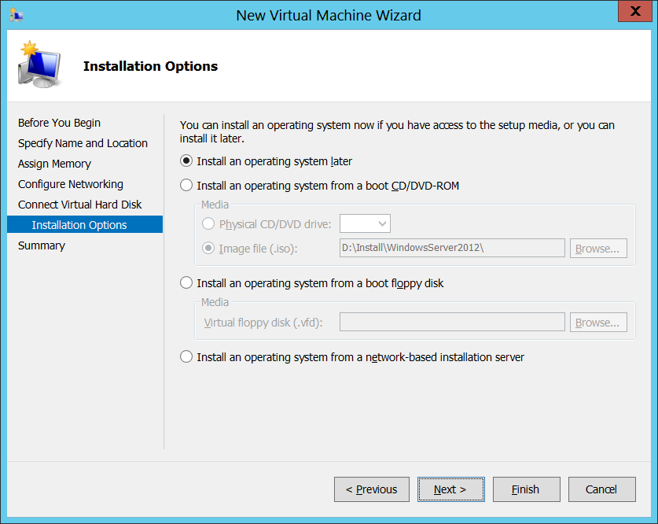

1. On the **Completing the New Virtual Machine Wizard** dialog, review the setting and verify that these settings are what you expected. Click **Finish** to create the new VM.

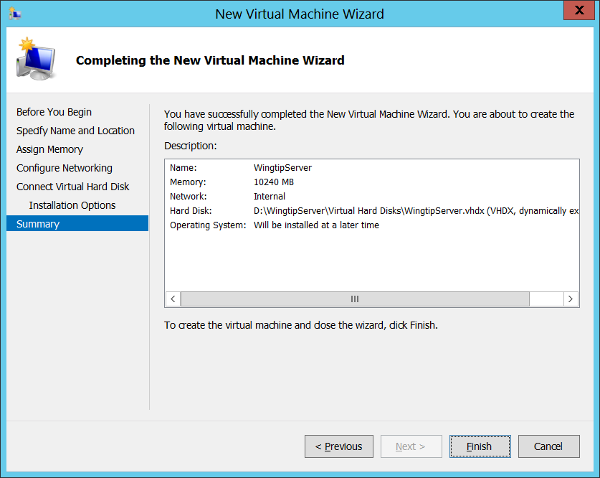

Even though you have finished going through the New Virtual Machine Wizard, there are still two more configuration changes you need to make on the VM before you are ready to install the Windows Server 2012 operating system.

1. In the **Hyper-V Manager** window, right-click the VM you just created and select **Settings**:

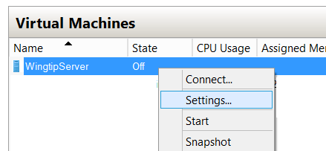

1. In the **Settings for WingtipServer** dialog, complete the following steps
   1. Select the **Processer** setting and increment the **Number of processors** property value from its default value of **1** to the maximum allowable number for your host machine. You can increment the **Number of processors** property value using the up arrow in the spinner control to its right. Depending on the processor capabilities of your host computer, you should be able to increase this property to a value of either **2**, **4** or **8**.

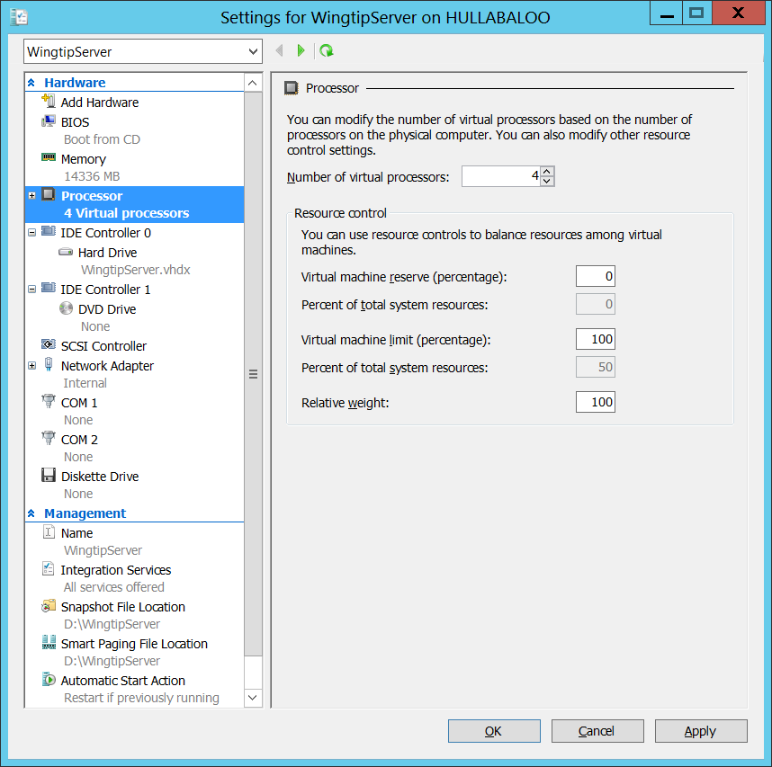

* 1. Click the **Apply** button to save your changes to the **Number of virtual processors** property while leaving the dialog open.

1. Create a second network adapter in the VM.
   1. In the **Settings for WingtipServer** dialog, select **Add Hardware**. Next, select **Network Adapter** and click **Add**:

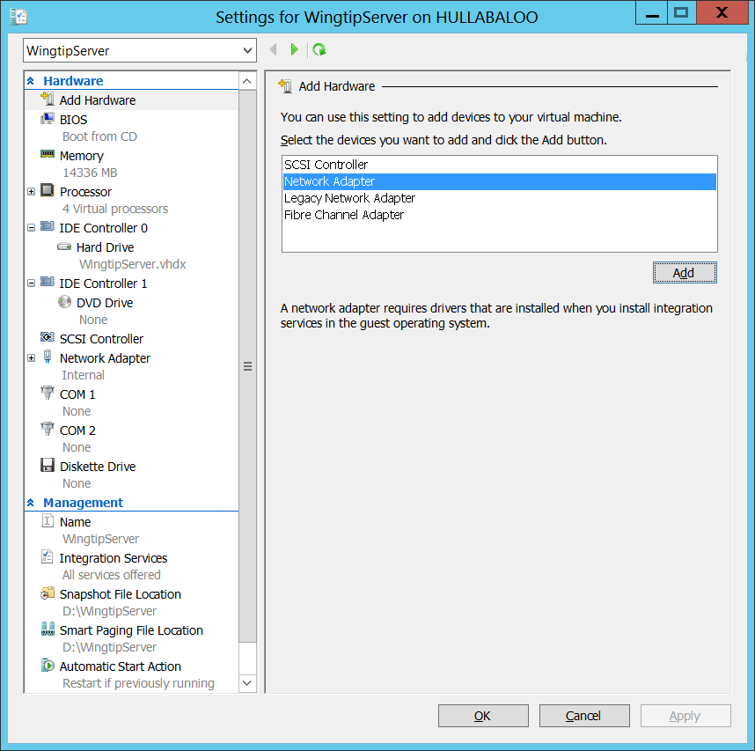

* 1. Once the new Network Adapter has been created, do **not** assign a **Virtual switch** yet. In an upcoming task later this setup guide you will bind this network adapter to the **External** virtual switch. For now, however, you should leave the **Virtual switch** setting with its default value of **Not connected**.

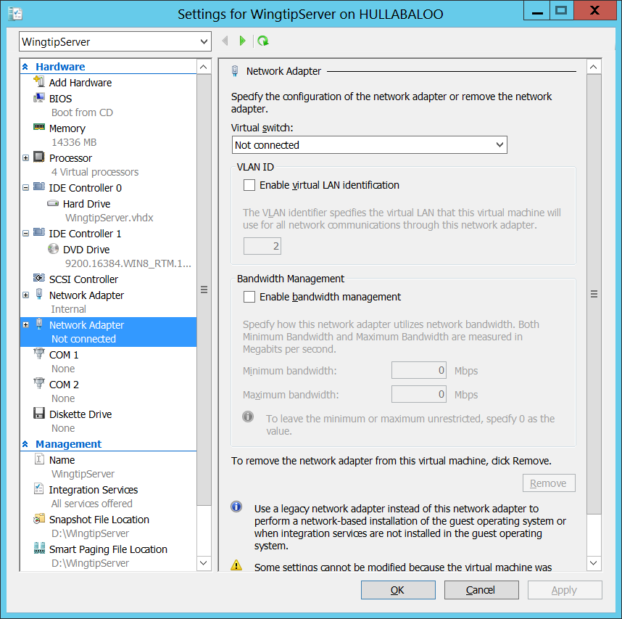

* 1. Click **OK** to save the changes you have made to the VM.

As this point you have created and configured a new VM. You are now ready to install Windows Server 2012.

### Task 4: Install Windows Server 2012

You will begin this task by acquiring the installation files and optionally a product key for Windows Server 2012. After that you will move through the steps of installing the operating system and configuring the VM as a server computer named **WingtipServer**.

1. Obtain a copy of the Windows Server 2012 install binaries.
   1. Choose between using your own licensed copy of Windows Server 2012 or using a free trial version.
      1. Note that downloading the free trial version will require that you have a TechNet or an MSDN subscription.
   2. If you plan to use a licensed copy, acquire the install image (*.iso) for of Windows Server 2012 and the product key.
   3. If you plan to use a free trial copy of Windows Server 2012, follow these steps:
      1. Navigate to the evaluation down page at **http://technet.microsoft.com/en-us/evalcenter/hh670538.aspx**.
      2. Find the **Download the Evaluation ISO** section and click the **Get Started Now** button underneath to begin the download.
      3. When prompted, log in using the credentials for your TechNet or MSDN subscription.
      4. Work through the instructions for downloading the Windows Server 2012 installation files in the .ISO file format.
      5. When you are done, you should have successfully downloaded the .ISO file with the Windows Server 2012 installation files to the hard drive of your host computer.
2. Mount the .ISO file so the **WingtipServer** VM recognizes it as a DVD.
   1. Navigate to **Hyper-V Manager**.
   2. Right-click the **WingtipServer** VM and select the **Connect…** command to display the Hyper-V console window for this VM.

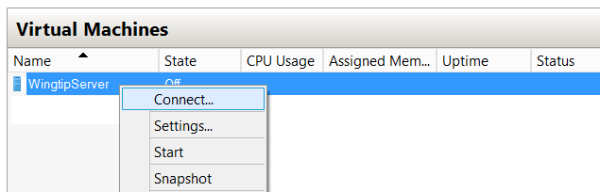

* 1. In the Hyper-V console windows for the **WingtipServer** VM, select the **Insert Disk…** command.

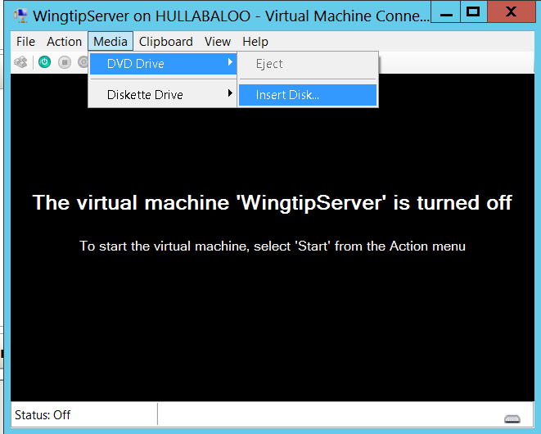

* 1. When the **Open File** dialog appears, enter the path to the .ISO file with the Windows Server 2012 installation files.
  2. Click **OK**.

1. Start the **WingtipServer** VM.
   1. In the Hyper-V console windows for **WingtipServer**, select the **Start** command from the **Action** menu to start up the VM.

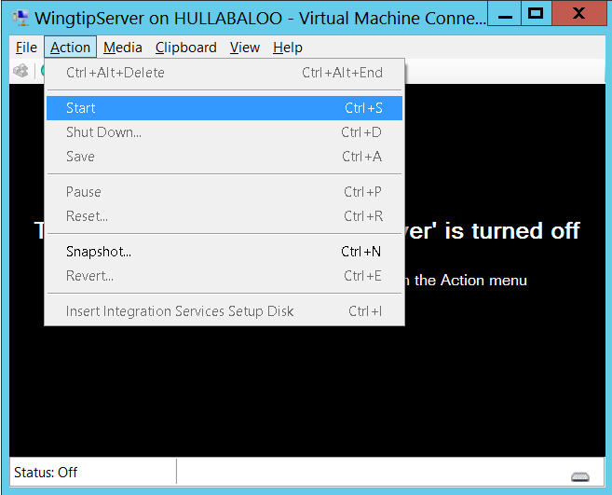

When the **WingtipServer** VM starts, it should automatically start the Windows Server 2012 installation program.

1. After the setup program for Windows Server 2012 loads, it will prompt you with a dialog asking you to select a language. Accept the default of **English** and click **Install** to continue.

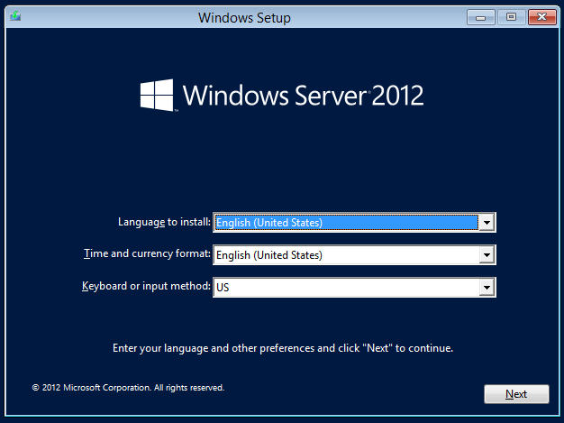

1. At the next dialog, click the **Install Now** button to begin the installation.

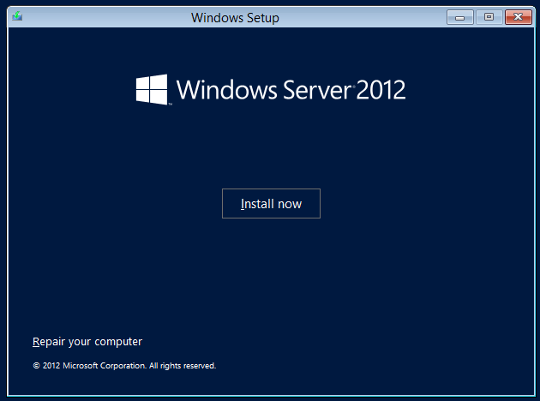

1. Depending on the type of installation files you have for Windows Server 2012, you might be prompted with a dialog which asks you to provide your Windows Server 2012 product key. If so, enter your product key and click **Next**.

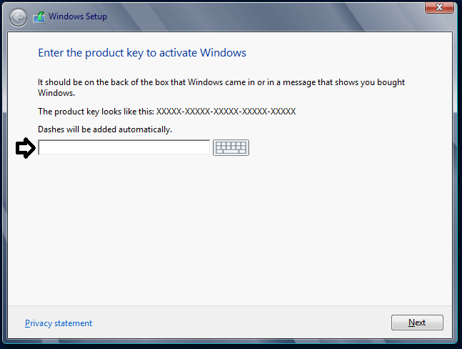

1. Depending on the type of installation files you have for Windows Server 2012, you might be prompted with a dialog which asks you to select the operating system you want to install. If so, select the 64-bit edition of **Windows Server 2012 Standard Evaluation (Server with a GUI)** and click **Next**.

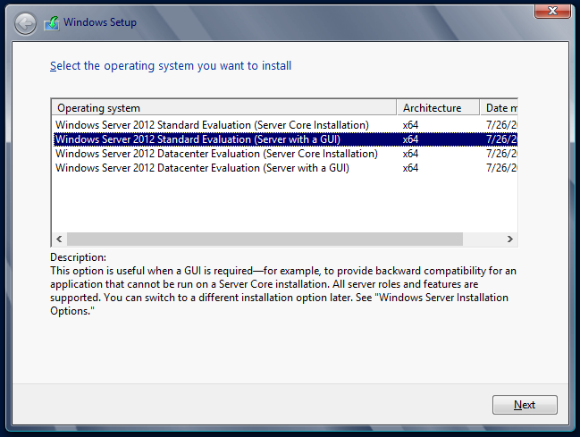

1. On the following dialog, agree to the licensing terms and click **Next**.
2. The next dialog prompts you with the question **Which type of installation do you want?**
   1. Select the installation type of **Custom: Install Windows only (advanced)**
   2. Click **Next**.

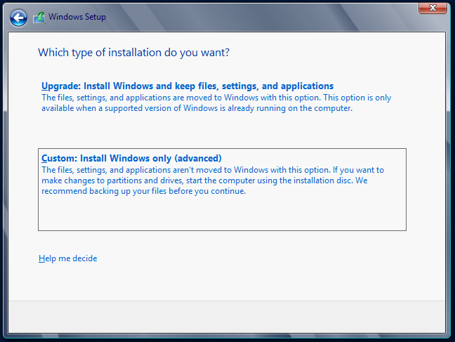

1. The next dialog asks you where you want to install Windows.
   1. Accept the default configuration which uses a location of **Disk 0 Unallocated Space** as shown below.
   2. Click **Next** to continue.

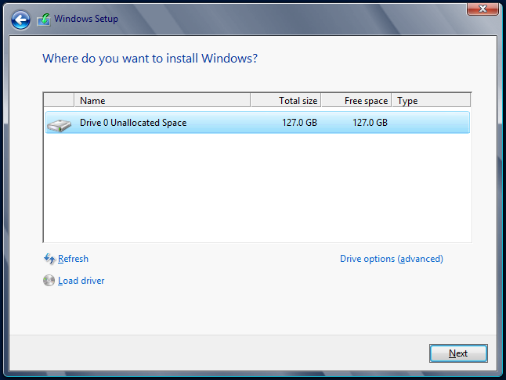

At this point you have given the Windows setup program enough information to install the basic operating system. The Windows Server 2012 setup program will now run for several minutes as it copies and expands files and installs Windows features. You now have a few minutes to get a cup of coffee or catch up on email.

1. Wait until the Windows Server 2012 setup program completes
2. When the setup program has completed, it will prompt you to assign a new password for the **Administrator** account.
   1. Click **OK** to continue and reset the administrator password.
   2. Set the password for the **Administrator** account to **Password1**.

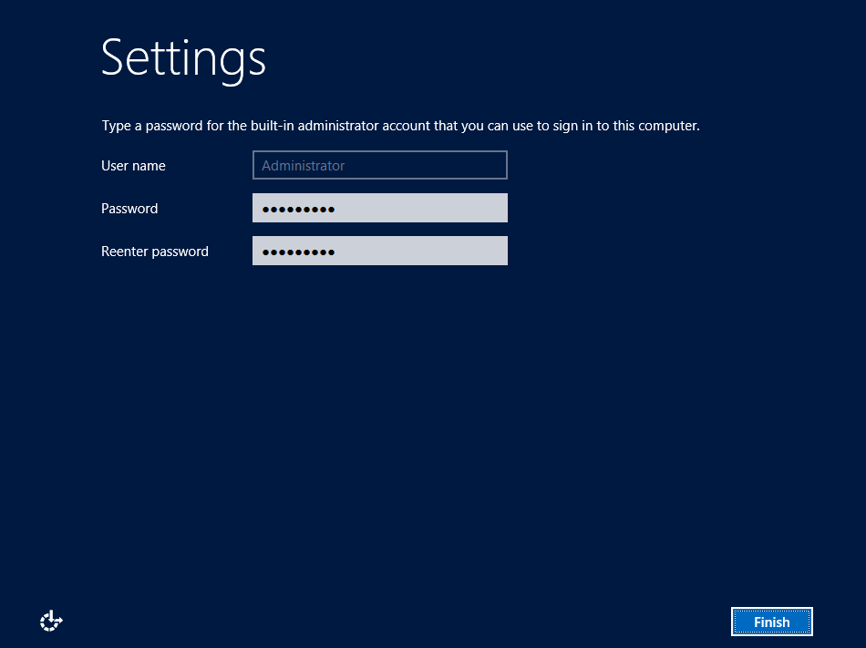

* 1. After you have updated the **Administrator** password, you will get a confirmation that the update was successful.
  2. Click **OK** to complete the basic installation of the operating system.
  3. When you click **OK** in the previous step, you will be logged off of the VM and the Hyper-V console window will then display the current date and time as well as the message **Press Ctrl + Alt + Delete to sign in**.



At this point, you have installed the basic operating system for Windows Server 2012 but there are several more configuration changes that you must make. Over the next few steps you will complete the required configuration by changing the computer name of the VM and making a few additional changes to the configuration of the operating system.

1. Log onto the VM using the local **Administrator** account.
   1. Do **not** attempt to log on by pressing the **Ctrl + Alt + Delete**.This keyboard combination will be sent to the host computer instead of the VM running inside Hyper-V.
   2. Log on to the VM by pressing the **Ctrl + Alt + End** keyboard combination or by selecting the **Ctrl + Alt + Delete** menu command inside the **Action** menu of the Hyper-V console window. When prompted to log on to the **Administrator** account, provide a password of **Password1**.

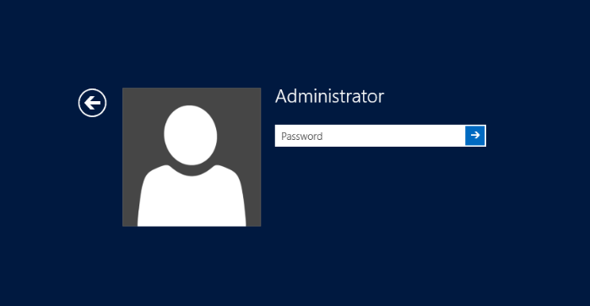

1. When you log in, Windows Server 2012 automatically displays the **Dashboard** page of the **Server Manager**. If you look at the left-hand portion of the screen, you will notice several navigation links including **Dashboard**, **Local Server**, **All Servers** and **File and Storage Services**.

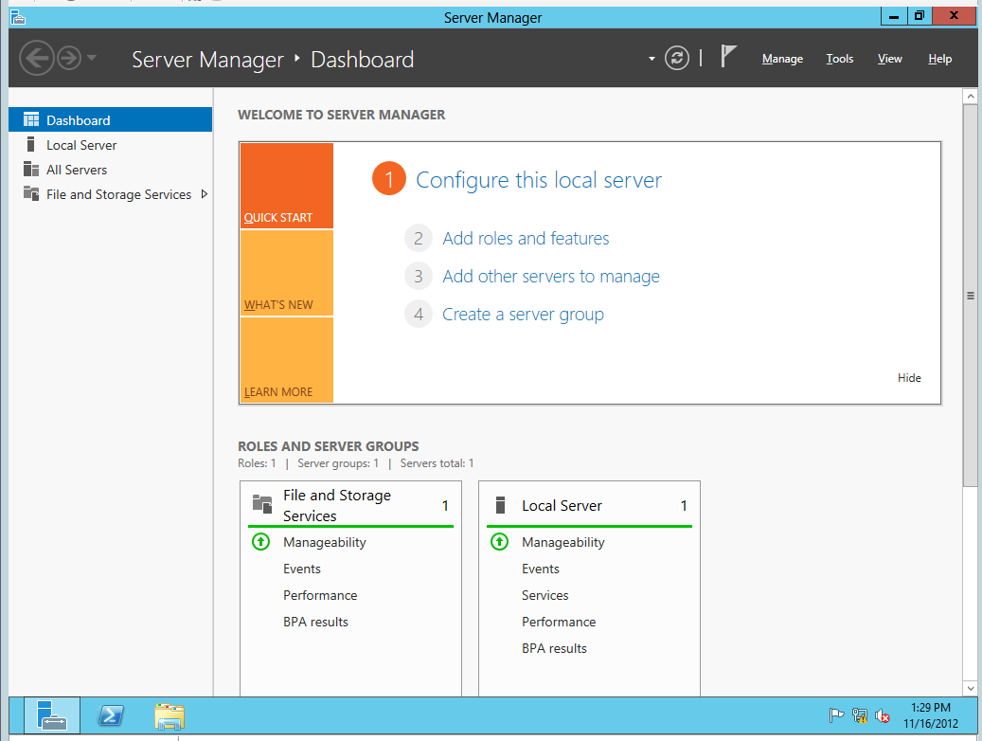

1. Click on **Local Server** link to navigate the main page used to update configuration properties of the local machine. You can see on the right-hand side of the screen there is a large section with a title of **Properties** which displays selected properties of the local machine.

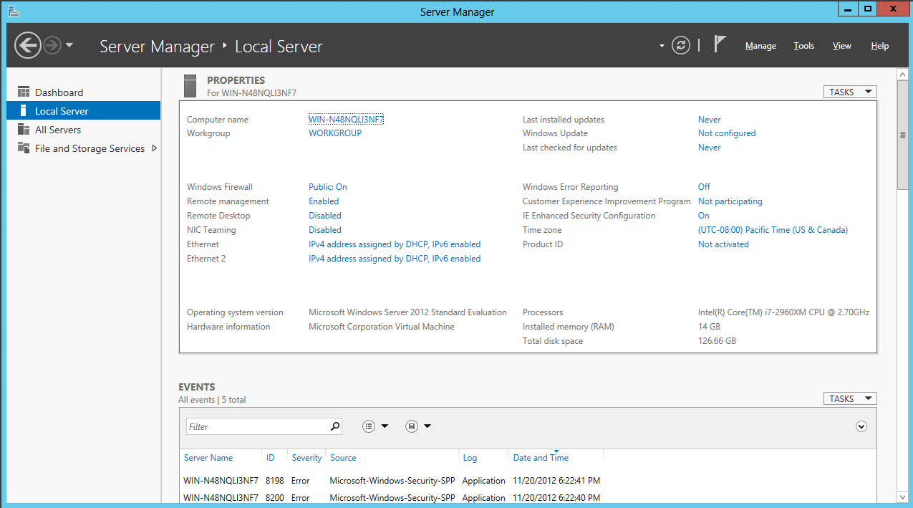

1. Change the **Computer name** of the VM to **WingtipServer**.
   1. Locate the **Computer name** property which is listed first in the **Properties** section. The current computer name was created by the Windows installation program as part of the initial setup of the operating system. Click on the value of the **Computer name** property to modify it.

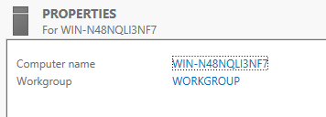

* 1. At this point you should be at the **Computer Name** tab of the **System Properties** dialog. Click on the **Change** button to update the **Computer name** property.

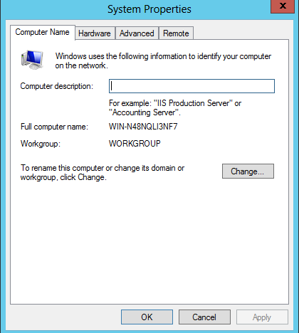

* 1. In the **Computer Name/Domain Changes** dialog, change the **Computer name** property to **WingtipServer**. Click **OK** to save your changes.

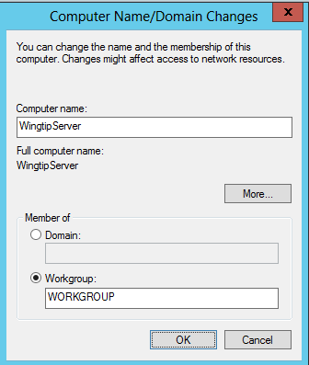

* 1. When you modify the **Computer name** property, Windows prompts you with a dialog that that tells you the machine needs to be restarted to apply the change. Choose **OK** to restart.
  2. After the VM has restarted, log in again using **[Administrator | Password1]** *(username | password)*.

1. Once you have logged back onto the VM, navigate back to the **Server Manager** and click the **Local Server** node. At this point, you should be able to see the **Properties for WingtipServer** section in the **Server Manager**.

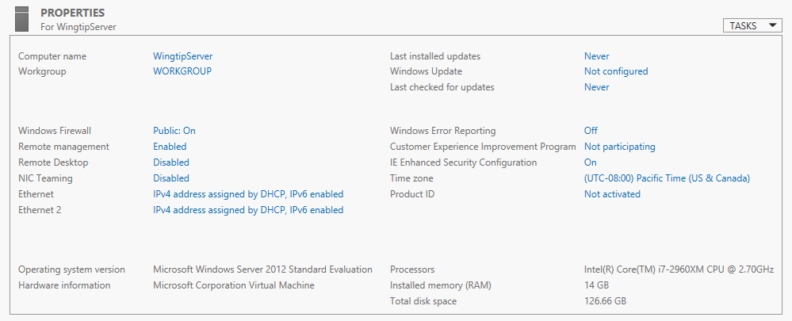

1. Disable **Enhanced Security Configuration**.
   1. In the **Properties for WingtipServer** section of the **Server Manager**, locate the **IE Enhanced Security Configuration** property in the right-hand column.
   2. You should be able to see that the **Enhanced Security Configuration** mode is configured to be on by default.
   3. Click on the value of **On** to display the **Internet Explorer Enhanced Security Configuration** dialog. This will display the **Internet Explorer Enhanced Security Configuration** dialog.
   4. In the **Internet Explorer Enhanced Security Configuration** dialog, disable **Enhanced Security Configuration** for both **Administrators** and **Users** by selecting the **Off** radio buttons as shown below and then click **OK**.

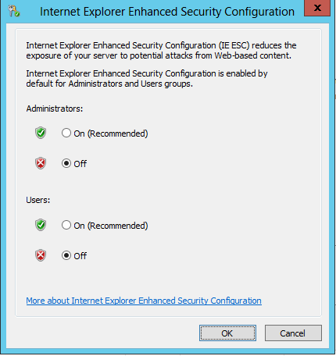

1. Disable the Windows Firewall.
   1. In the **Properties for WingtipServer** section of the **Server Manager**, locate the **Windows Firewall** property which shows an initial value of **Public: On**. Click on the value of **Public: On** to display the **Windows Firewall** dialog.
   2. In the **Windows Firewall** dialog, locate and click the **Advanced Settings** link to display the **Windows Firewall Advanced Settings** dialog.

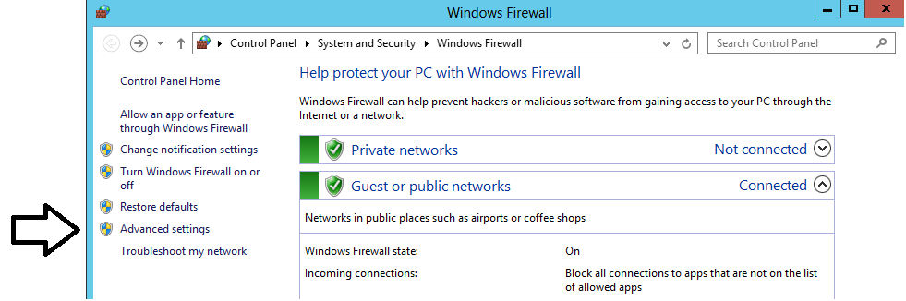

* 1. In the **Windows Firewall Advanced Settings** dialog, you should be able to see that the Windows Firewall for the **Domain Profile**, the **Private Profile** and the **Public Profile** are all enabled. Locate and click the **Windows Firewall Properties** link at the bottom of the **Overview** section to display a tabbed dialog with the title of the **Windows Firewall with Advanced Security on Local Computer**.

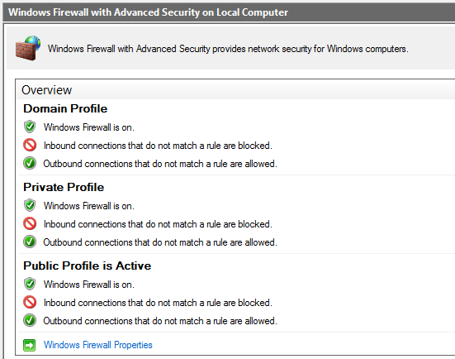

* 1. In the **Domain Profile** tab of the **Windows Firewall with Advanced Security on Local Computer** dialog, change the **Firewall state** property setting from **On** to **Off**. Click **Apply** to save your changes while leaving the tabbed dialog open.

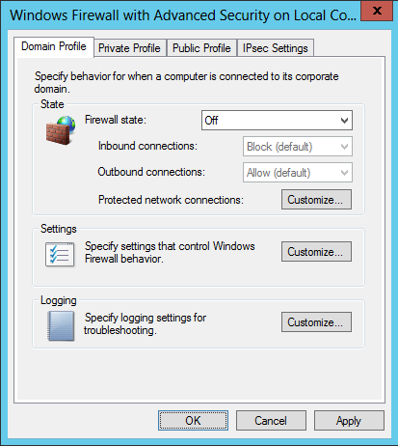

* 1. Once you have configured the **Firewall state** property to **Off** on the **Domain Profile** tab, go to the **Private Profile** tab and then the **Public Profile** tab and follow the same steps to disable the firewall for these profiles as well.
  2. Once you have turned off the firewall for all three profiles, click **OK** to dismiss the dialog. You should be able to verify in the **Overview** section of the **Windows Firewall Advanced Settings** dialog that the Windows Firewall has been turned off for the **Domain Profile**, the **Private Profile** and the **Public Profile**.

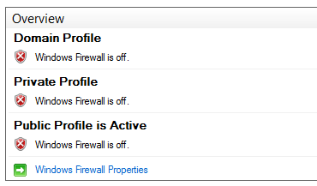

1. Enable Remote Desktop for your VM:
   1. Navigate back to the **Server Manager** and click the **Local Server** node. At this point, you should be able to see the **Properties for WingtipServer** section in the **Server Manager**.
   2. Look inside the **Properties for WingtipServer** section and locate the **Remote Desktop** property which an initial value of **Disabled**.

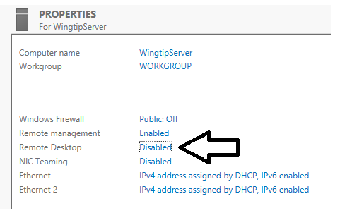

* 1. Click on the **Remote Desktop** property value of **Disabled.** This willdisplay the **Remote** tab of the **System Properties** dialog.
     1. Select the radio button option **Allow for remote connections to this computer**.
     2. Check **Allow connections only from computers running Remote Desktop with Network Level Authentication**.
     3. Click **OK** to save changes and dismiss the **System Properties** dialog.

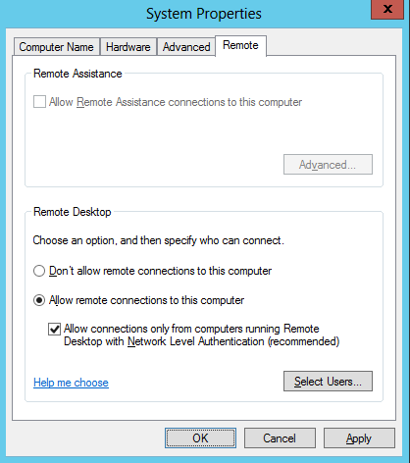

1. Configure the local **Administrators** account so the password never expires.
   1. Navigate to the **Properties for WingtipServer** section of **Server Manager** > **Local Server**.
   2. Look at the top-right corner of the **Properties for WingtipServer** section and locate the **Tasks** menu. Drop down the **Tasks** menu and select the **Computer Management** menu command to display the Windows server **Computer Management** utility.

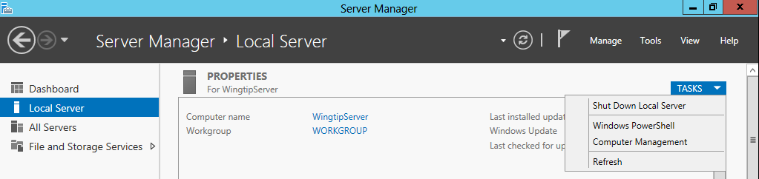

* 1. When the **Computer Management** utility appears, you can see that it provides a tree view control of nodes that represent various configurable components and services on the local machine. Within this collection of nodes, you should be able to locate the **Local Users and Groups** node.

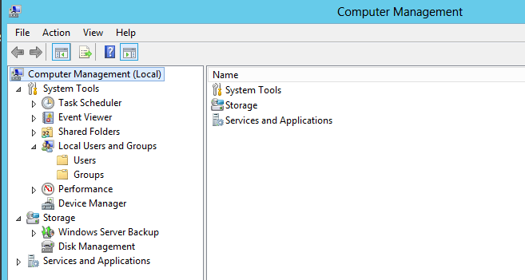

* 1. Navigate to **Local Users and Groups 🡪** **Users** and locate the local **Administrator** account.
  2. Right-click on the **Administrator** account and click **Properties**.

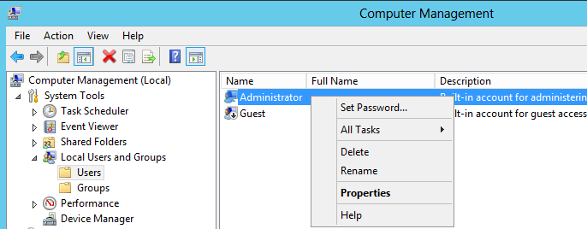

* 1. In the **Administrator Properties** dialog, select the option for **Password never expires**.

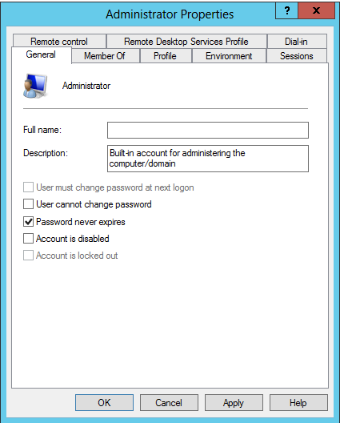

* 1. Click **OK** to save your changes and close the **Administrator Properties** dialog.
  2. Return to the **Local Server** page of the **Server Manager**.

1. Rename the two network connections so you can tell them apart.
   1. Click on the **Windows** key on the keyboard to bring up the Windows Server 2012 **Start page**.
   2. Your **Start page** should appear as the one shown below.

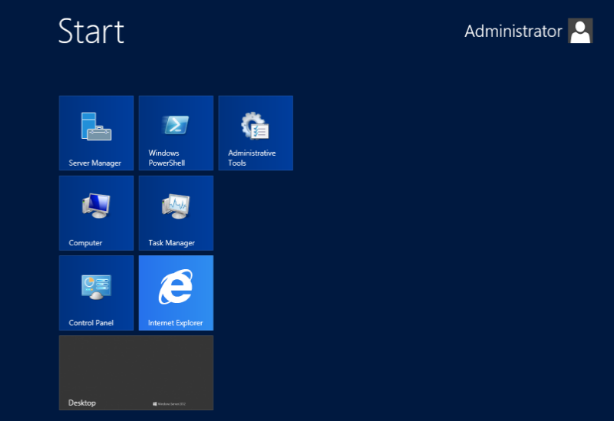

* 1. With the **Start page** showing, go to the keyboard and type in **"View Network Connections"**. Click on the **Settings** link on the right as shown in the following screenshot. You should see that Windows found the **View network connections** page. Click on **View network connections** to navigate to that page.

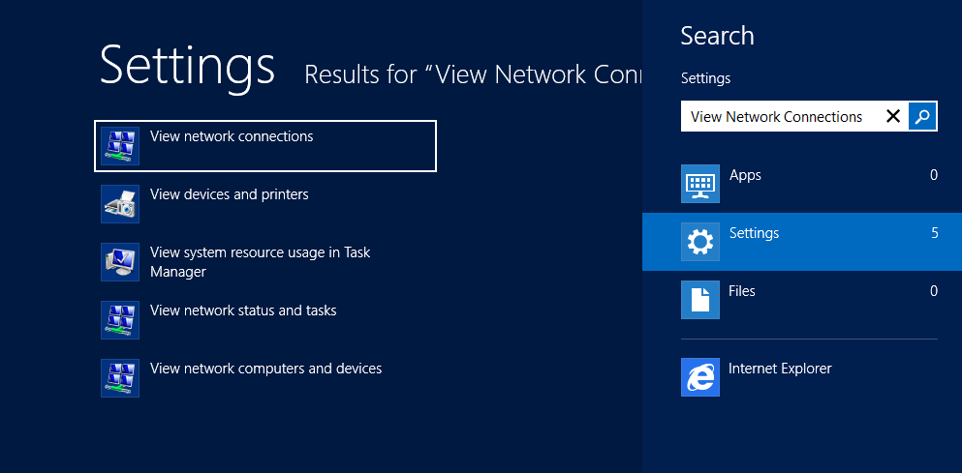

* 1. On the **View network connections** page, you should see that the VM has two network connections. You should also be able to see that one of them is connected and the other one with the big red X is disconnected.

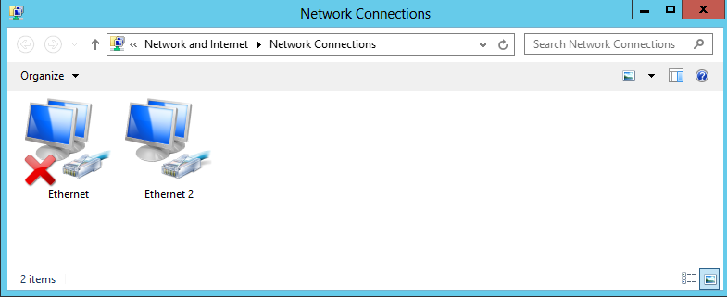

The network connection which is connected is based on network adapter for the VM which is assigned to the virtual switch named **Internal**. The other network connection which is disconnected (e.g. unplugged) has a network adapter that is not currently assigned to a virtual switch. The reason we had you leave the second network adapter unassigned earlier in the setup guide is that it makes it easier to see which network connection is which when initially configuring the VM.

* 1. Right-click the network connection which is connected and select **Rename**. Give it a name of **Internal**.
  2. Right-click the network connection which is disconnected and select **Rename**. Give it a name of **External**.

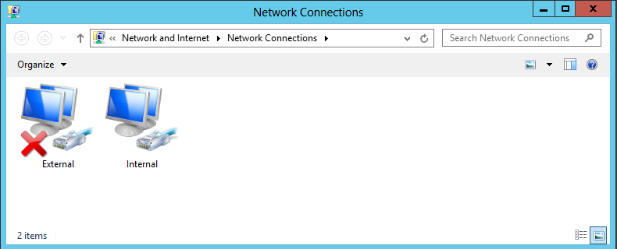

1. Configure a static IP address on **Internal** network connection.
   1. Right-click the **Internal** network connection and select **Properties**.
   2. Uncheck the item **Internet Protocol Version 6 (TCP/IPv6)**
   3. In the **Internal Properties** dialog, select the **Internet Protocol Version 4 (TCP/IPv4)** item and click **Properties**.

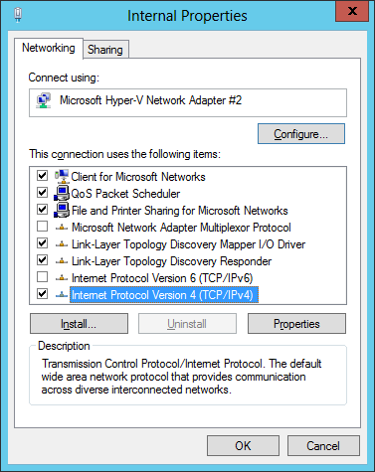

* 1. In the **Internet Protocol Version 4 Properties** dialog, select the option **Use the following IP address** and enter the following configuration settings:
     1. IP Address: 192.168.150.1
     2. Subnet mask: 255.255.255.0
  2. In the **Internet Protocol Version 4 Properties** dialog, select the option **Use the following DNS Server Addresses** and enter the following configuration setting:
     1. Preferred DNS Server: 192.168.150.1

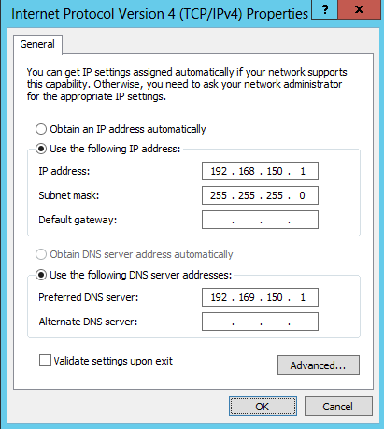

* 1. Click **OK** to accept the IP settings and **Close** the **Internet Protocol Version 4** dialog.

1. Configure the **External** network connection inside the VM to connect to the Internet:
   1. Open the **Network Connections** window if it is not still open using the same steps from the previous step.
   2. Right-click the **External** network connection and select **Properties** to display the **External Properties** dialog.
   3. Uncheck the item **Internet Protocol Version 6 (TCP/IPv6)**
   4. Select the **Internet Protocol Version 4 (TCP/IPv4)** item and click **Properties**.
   5. Enter the following information into the resulting dialog to configure the network connections IP settings:
      1. Select the radio button option **Obtain an IP Address Automatically**
      2. Select the radio button option **Use the following DNS server addresses**.
      3. Set the **Preferred DNS Server** to **127.0.0.1**.
      4. Set the **Alternate DNS Server** to **4.2.2.4**.

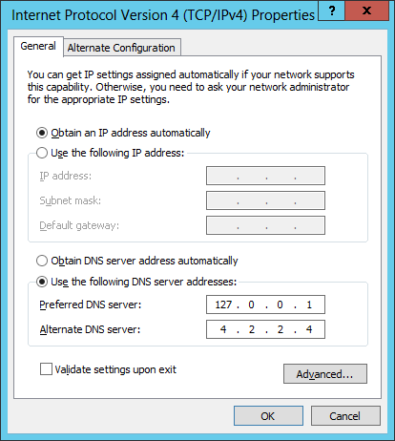

* 1. Click **OK** to accept the IP settings and **Close** the **Internet Protocol Version 4** dialog.

Setting the DNS server addresses for the **External** network connection is important. These settings will ensure that the VM always looks to its local DNS service first when attempting to resolve an Internet domain name to an IP address. The second IP address of **4.2.2.4** is a well-known address of a DNS server on the Internet. This configuration ensures that the VM will always have a secondary DNS service to look up domains on the Internet that the local DNS service cannot find.

1. Reconfigure the VM's network adapter in Hyper-V to bind it to the **External** virtual switch.
   1. Go back to the host computer and open the Hyper-V Manager.
   2. In the Hyper-V Manager window, right-click the VM named **WingtipServer** and select **Settings**.
   3. Select the second Network Adapter, the one that is not connected.
   4. For the **Virtual switch** setting, select **External** and click **OK**. This will effectively connect the **External** network connection in the **WingtipServer** VM to your local LAN and your local DHCP service.

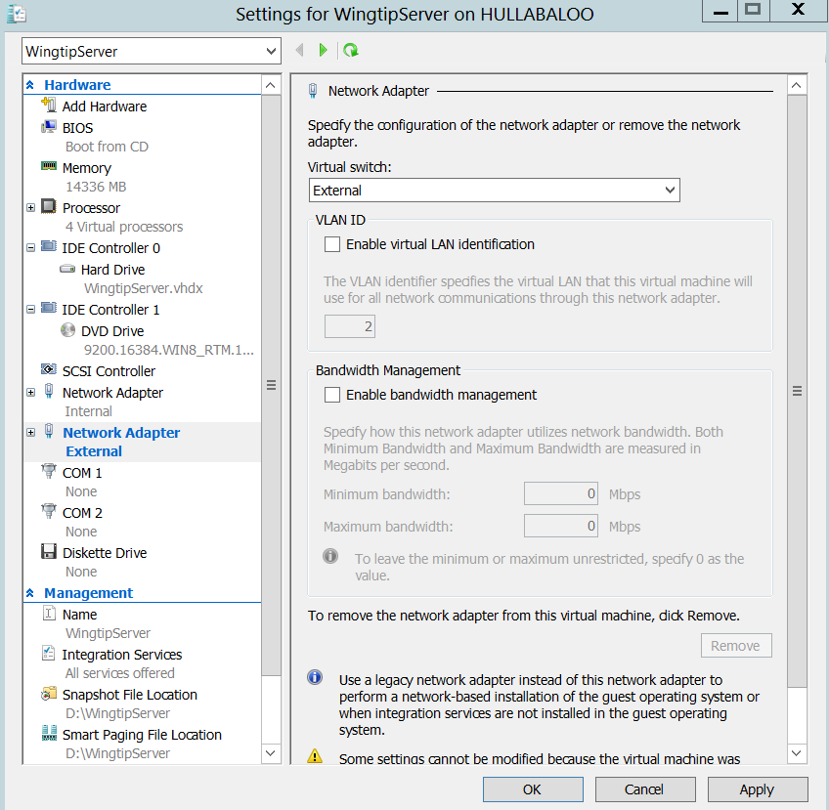

* 1. Return back into the user interface of the **WingtipServer** VM.
  2. Navigate back to the **View network connections** page. You should now see that both network connections show they are connected. In other words, the big red X should have disappeared.

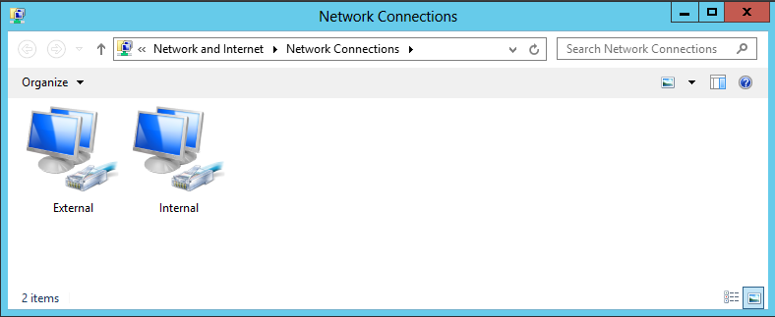

* 1. Refresh the **External** network connection
     1. Select the **External** network connection you just plugged in
     2. With the **External** network connection selected, click the **Disable this Network Device** button in the toolbar.
     3. With the **External** network connection selected, click the **Enable this Network Device** button in the toolbar
     4. When the network connection is re-enabled, Windows uses the **External** network connection to call out to the local DHCP service to acquire an IP address that will make it possible for the **WingtipServer** VM to access the Internet.
     5. Open the Internet Explorer and browse to a site on the Internet such as **http:www.bing.com**. You should be able to browse sites on the Internet without any problems.

1. Run the **ipconfig.exe** utility to verify that the VM's IP addresses have been configured properly.
   1. Press the **Windows** key + **R** key keyboard combination to bring up the Windows **Run** menu.
   2. In the **Run** dialog, type in **cmd** and click **OK** to bring up a standard Windows command prompt.

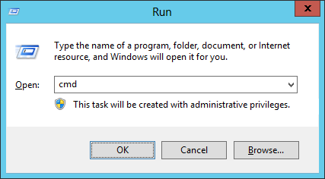

* 1. In the command prompt, run the **ipconfig** command to view the IP address that have been assigned to the **WingtipServer** VM. You should be able to verify that that the **Internal** network connection has the static IP address you assigned which is **192.168.150.1**. You should also be able to verify that that the **External** network connection has been assigned a dynamic IP address by your local DHCP service.

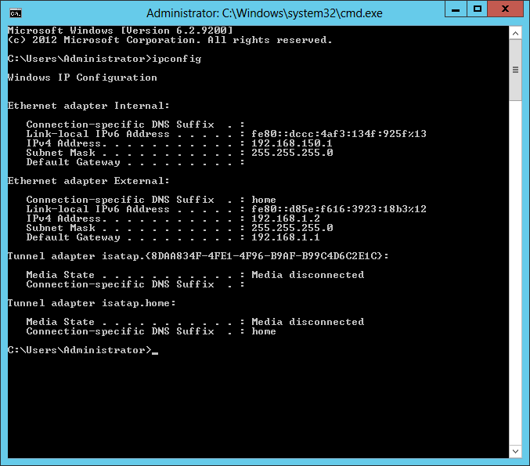

1. Configure the Windows Update settings for the **WingtipServer** VM.
   1. Click on the **Windows** key on the keyboard to bring up the Windows Server 2012 **Start menu**.
   2. With the **Start menu** showing, go to the keyboard and type in **"automatic updating"**. Click on the **Settings** link on the right as shown in the following screenshot. You should see that Windows found the **Turn automatic updating on or off** page. Click on **Turn automatic updating on or off** to navigate to the **Choose your Windows Update settings** page.

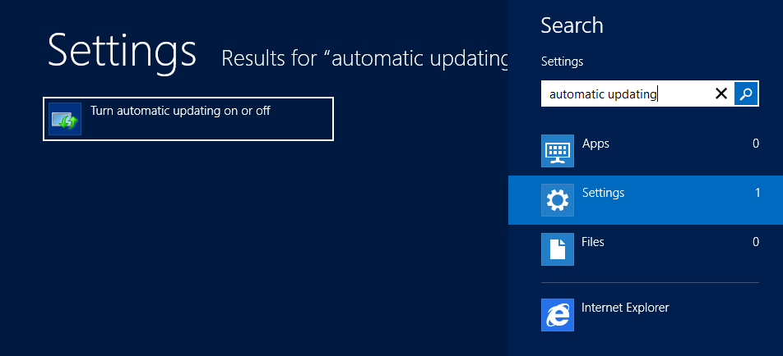

* 1. The **Choose your Windows Update settings** page shown below provides a dropdown menu that allows you to configure how the **WingtipServer** VM will deal with getting Windows Updates. Select the option for **Never check for updates (not recommended)** as shown in the screenshot below and then click **OK** to close the dialog.

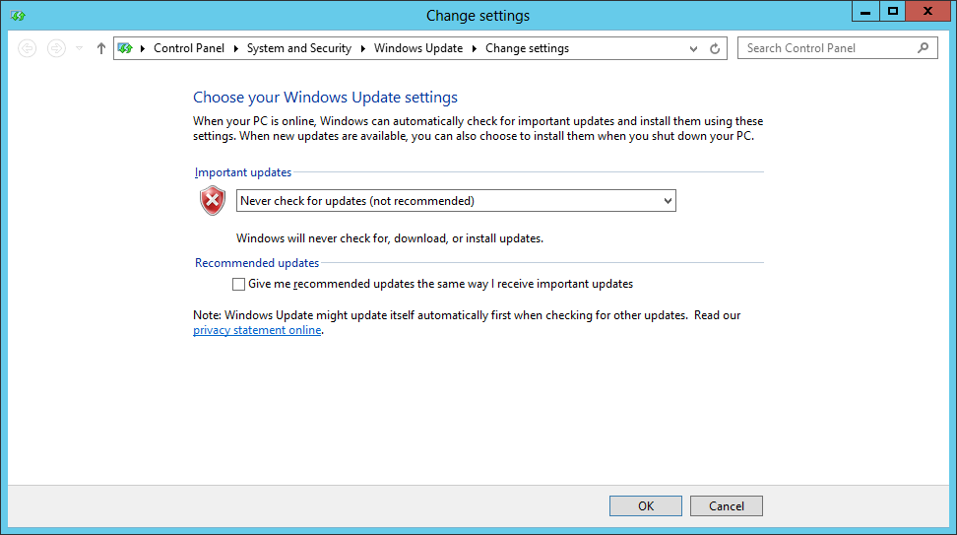

Configuring a computer with a setting of **Never check for updates** isn’t what you should use in a production environment. However, it is usually the good choice for a VM which has been created to provide a lab environment because you don't want to be taken by surprise by Windows updates that change the local computer configuration or interrupt the network connection. Instead of configuring Windows to apply updates automatically, you will now run Windows update manually a single time to apply all the important updates and recommended updates to get the **WingtipServer** VM up to date.

1. Update the **WingtipServer** VM with the latest updates using **Windows Update**
   1. Click on the **Windows** key on the keyboard to bring up the Windows Server 2012 **Start menu**.
   2. With the **Start menu** showing, go to the keyboard and type in **"install updates"**. Click on the **Settings** link on the right as shown in the following screenshot. You should see that Windows found the **Install optional updates** page. Click on **Install optional updates** to navigate to the **Windows Update** page.

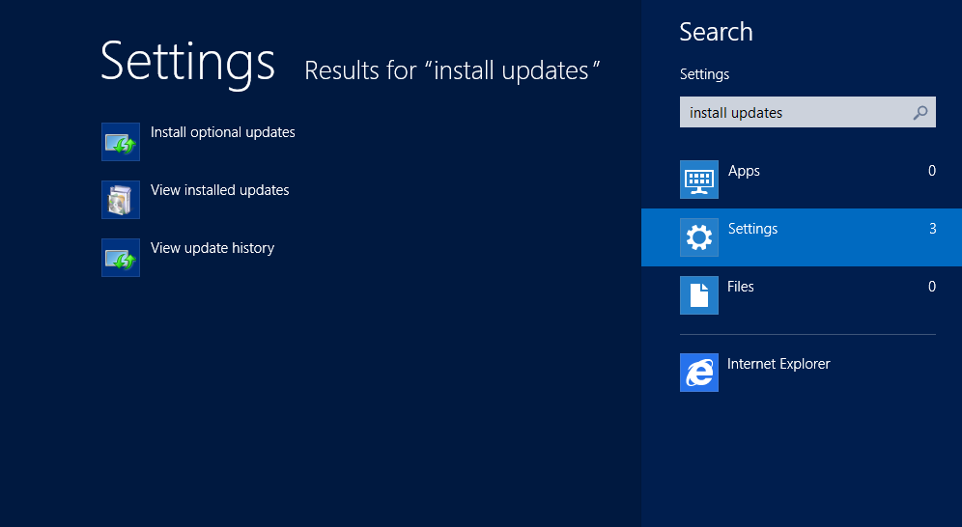

* 1. On the Windows Update page, click the **Check for** **Updates** button. When you click this button, the Windows operating system will communicate with the Windows Update service on the Internet to determine which Windows updates are available for installation.

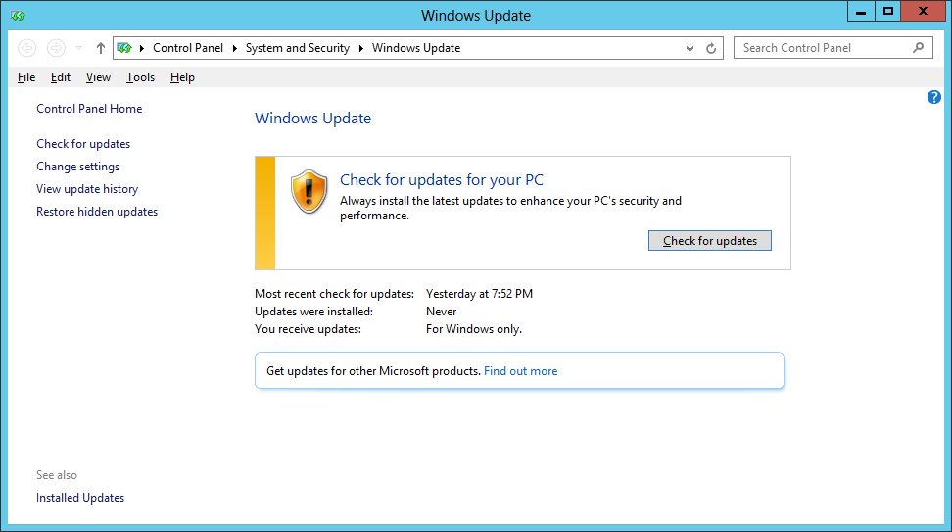

* 1. The **Windows Update** page will prompt you to install any available updates. Click the **Install updates** button to install all important and recommended updates. If you are prompted, select **I accept the license terms** for any updates that require it.

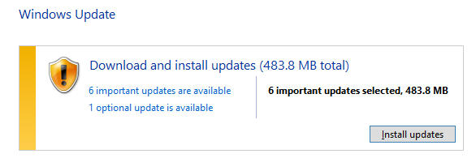

This step can take quite a bit of time so be patient.

* 1. If you are prompted to restart your PC during the Windows Update process, click **Restart now** and wait for the VM to restart. Once the VM restarts, log in as **Administrator** and navigate back to the **Windows update** page as you did earlier in this step by searching for **"install updates"** on the Windows Start page.

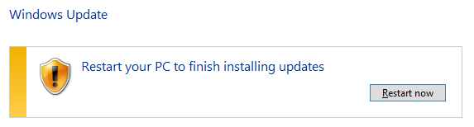

* 1. Once the first round of updates have been installed, click on **Check for updates** button again on the **Windows Update** page. Repeat the process of running Windows Update, checking for updates and installing them (rebooting if required) until the **Windows Update** page reports that **Your PC is up to date** as shown in the following screenshot.

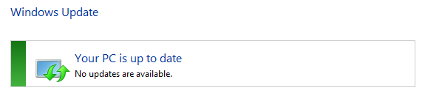

* 1. On you have applied all the important and recommended updates, close the **Windows Update** page.

1. If you have a Windows Server 2012 product key, activate the Windows operating system.
   1. If you are using the trial version of Windows Server 2012, you should skip this step and move ahead to the next step.
   2. Click on the **Windows** key on the keyboard to bring up the Windows Server 2012 **Start menu**.
   3. With the **Start menu** showing, go to the keyboard and type in **"Windows Activation"**. Click on the **Settings** link on the right as shown in the following screenshot. You should see that Windows found the **Windows Activation** page. Click on **Windows Activation** to navigate to the **Windows Activation** page.

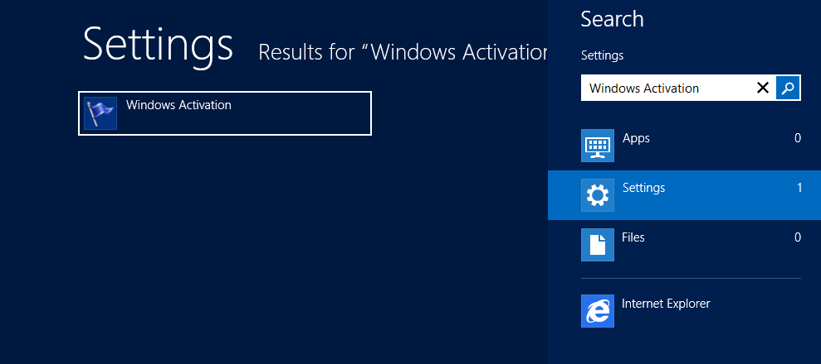

* 1. On the **Windows Activation** page, follow the step to activate your copy of Windows Server 2012.
  2. Once you have activated the Windows operating system, close the **Activate Windows** page.

At this point you have configured the **WingtipServer** VM with a fully updated version of Windows Server 2012. In the next task you will move ahead by configuring the **WingtipServer** VM to act as the Active Directory domain controller.

### Task 5: Install Active Directory Domain Services and Create a new Domain

Now you will promote the **WingtipServer** VM to a domain controller and create a new domain named **wingtip.com**

1. Navigate back to the **Dashboard** page of **Server Manager**.
   1. Press the **Windows** key to display the Windows **Start page**.
   2. Click the **Server Manager** tile to start up and navigate to the **Server Manager**.

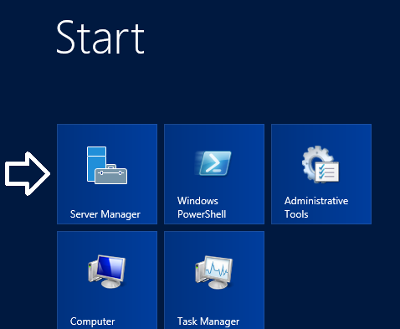

1. You should now be on the **Dashboard** page in the **Server Manager** where you can start the **Add Roles and Features Wizard**.
   1. On the right-hand side of the **Dashboard** page, locate the **Add roles and features** link.
   2. Click the **Add roles and features** link to start the **Add Roles and Features Wizard**.

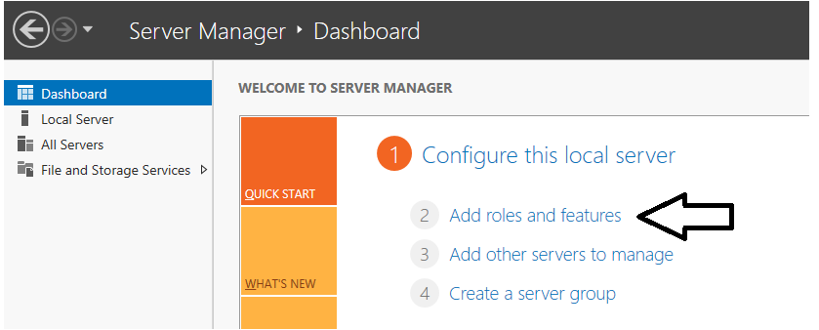

* 1. On the first page of the **Add Roles and Features Wizard**, check the box titled **Skip this page by default** and click **Next**.

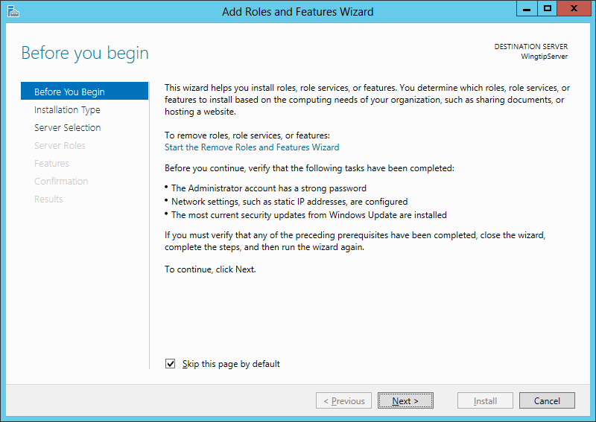

* 1. On the **Select installation type** page of the **Add Roles and Features Wizard**, do the following**:**
     1. Select the option **Role-based or feature-based installation**.
     2. Click **Next** to advance to the next page of the wizard.

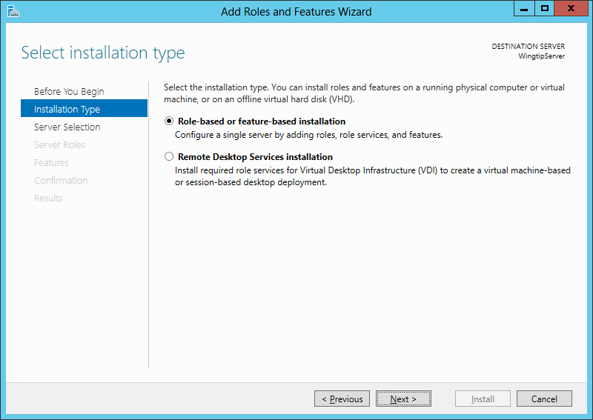

* 1. Do the following on the **Select destination server** page of the **Add Roles and Features Wizard.**
     1. Select the option **Select a server from the server pool**.
     2. Select **WingtipServer** from the **Server Pool**.
     3. Click **Next** to move to the next page.

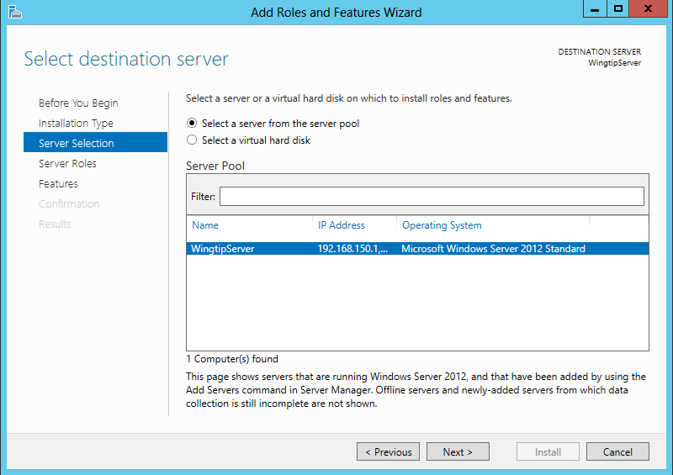

* 1. On the **Select server roles** page, select the role of **Active Directory Domain Services**. When you select this role, the wizard prompts you with the following dialog asking you to confirm you want to add the perquisite features required for this role.

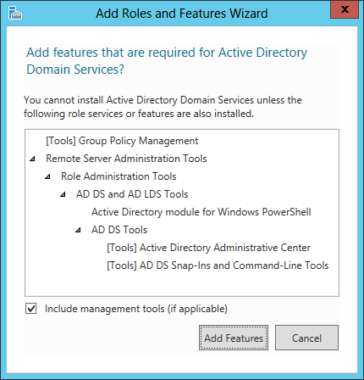

* 1. Respond to this dialog by clicking the **Add Features** button to confirm it is OK to install the perquisite features.
  2. Click **Next** on the **Select server roles** page to move on to the next page of the wizard.

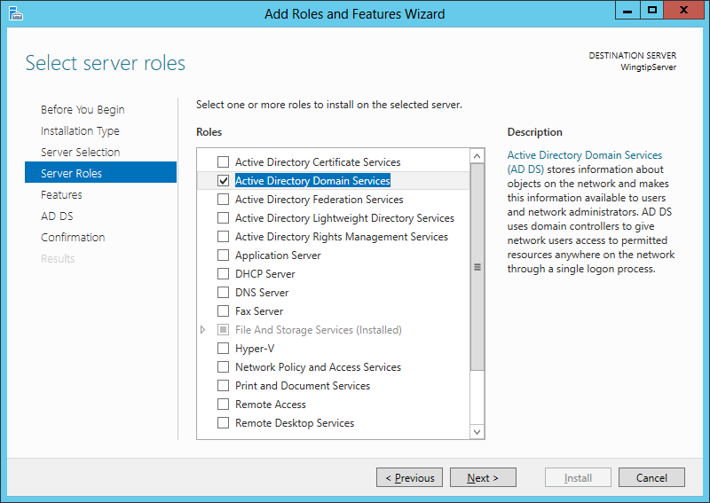

* 1. On the **Select features** page of the **Add Roles and Features Wizard**, there is no need to select any additional features. Click **Next** advance to the next page in the wizard.

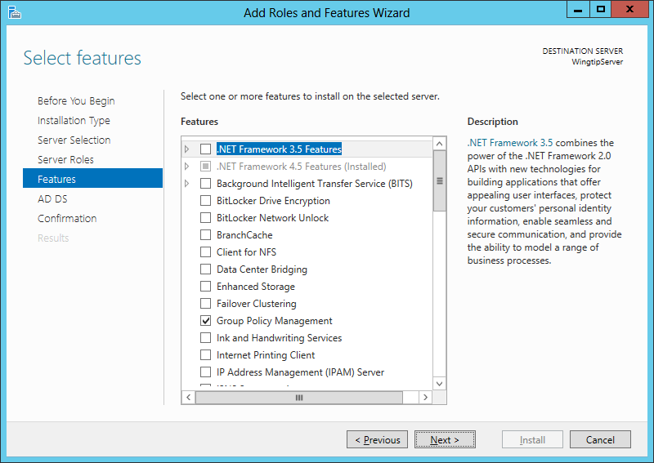

* 1. The next page provided by the wizard displays information about how Active Directory Domain Service will be installed.
     1. Click **Next t**o move to the next page of the wizard**.**
  2. The next page in the **Add Roles and Features Wizard** is the **Confirm installation selections** page. Complete these steps to start the installation of **Active Directory Domain Services**.
     1. Click the checkbox to enable the option **Restart the destination server automatically if required**.
     2. In the **Add Roles and Features Wizard** dialog box, click the **Yes** buttonto confirm you wish to allow automatic restarts.
     3. Click the **Install** button.

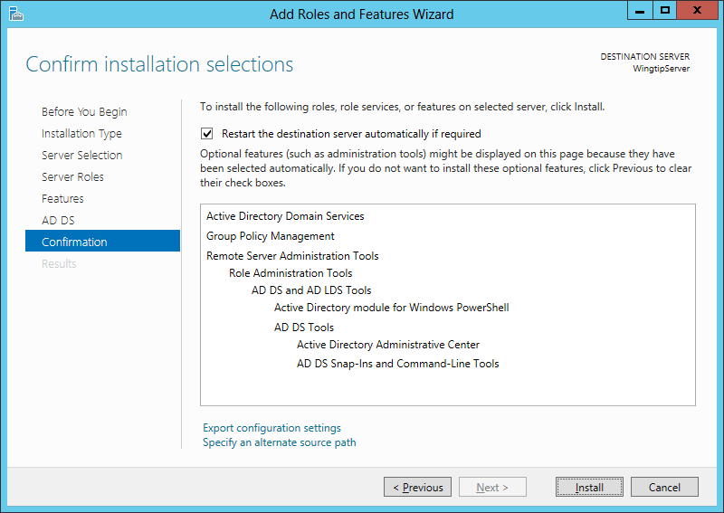

* 1. Installation will take several minutes and you will see its progress in the **Installation progress** page. After **Active Directory Domain Services** have been installed, the wizard displays a **Results** view which should indicate that the installation succeeded but additional configuration is required. Do **not** close the windows for the **Add Roles and Features Wizard** yet. You will need this window to remain open with the **Results** view showing to complete the next step.

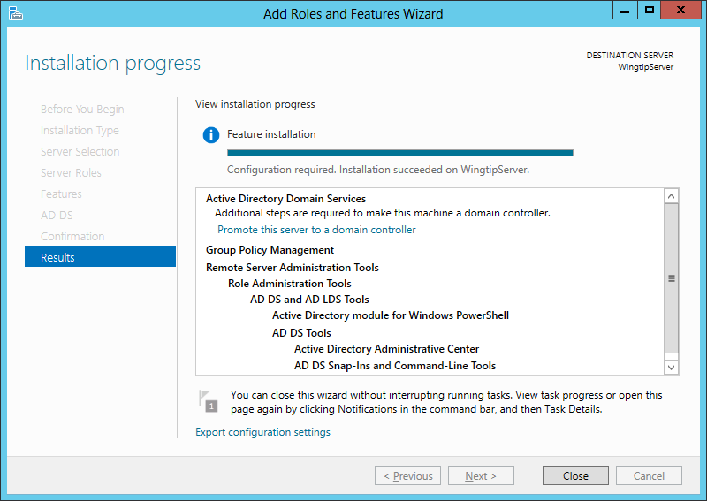

* 1. Look in the **Results** view of the dialog shown above and locate the **Promote this server to a domain controller** link.
  2. Click **Promote this server to a domain controller** to launch the **Active Directory Domain Services Configuration Wizard**.
  3. Move on to the next step to move through the details of using the **Active Directory Domain Services Configuration Wizard**.

With previous versions of Windows Server, you use a utility named **dcpromo.exe** when you need to create new a Active Directory domain and to promote a server to be a domain controller. However, the **dcpromo.exe** utility is now deprecated with Windows Server 2012. The **dcrpomo.exe** utility has been replaced by the **Active Directory Domain Services Configuration Wizard** which is part of **Server Manager**.

1. Use the **Active Directory Domain Services Configuration Wizard** to create a new Active Directory domain and promote the **WingtipServer** VM to be a domain controller.  
   (Note: when clicking the **Next** button to advance between screens in this wizard it may take up to several minutes before the next screen becomes functional (due to background configuration from prior screen). Please be patient.
   1. The first page of the **wizard** is the **Deployment Configuration** page.
      1. Select the radio button option **Add a new forest**
      2. Enter a **Root domain name** of **wingtip.com**.
      3. Click **Next** to move to the next page in the wizard.

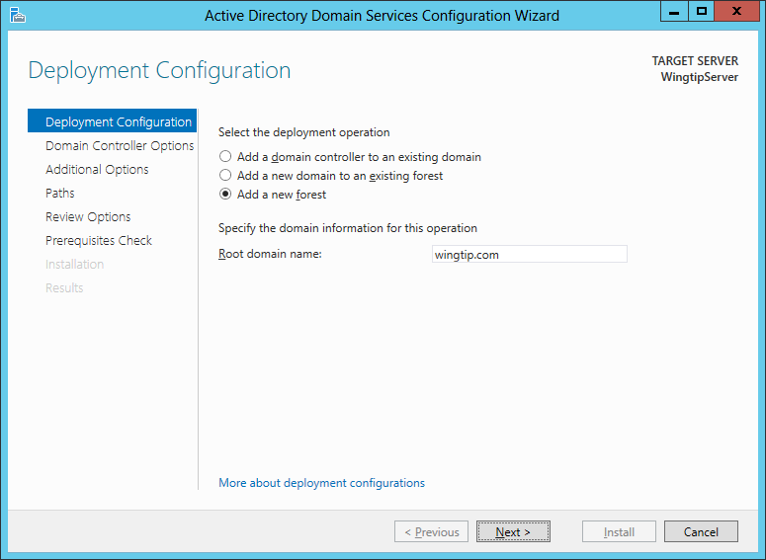

* 1. The next page is the **Domain Controller Options** page:
     1. Leave the default settings for **Forest function level** and **Domain functional level.**
     2. Leave the default settings for checkbox options for **Specify domain controller capabilities**.
     3. Locate the section with the caption **Type the Directory Services Restore Mode (DSRM) password** and type a password of **Password1** in the **Password** textbox and the **Confirm Password** textbox.
     4. Click **Next** to move to the next page.

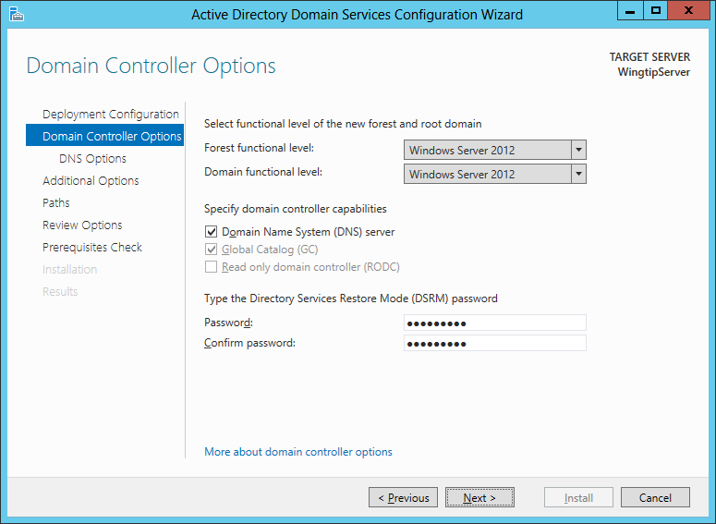

* 1. On the **DNS Options** page of the **Active Directory Domain Service Configuration Wizard** you will be prompted with a warning that Windows cannot find a delegation for this DNS server. You can ignore this warning because you will configure the **WingtipServer** VM to act as a top-level DNS server which needs no delegation. You don't need to do anything on this page other than clicking **Next** to continue to the next page in the wizard.

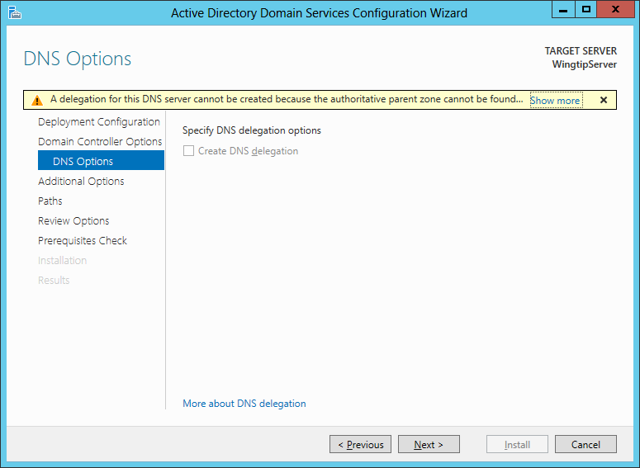

* 1. On the **Additional Options** page you are asked to verify that the NetBIOS domain name is **WINGTIP**.
     1. Accept the default value and click **Next** to continue to the next page in the wizard.

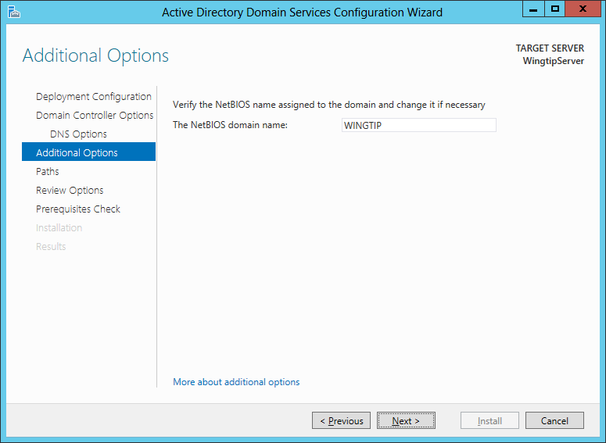

* 1. On the **Paths** page you should accept the default settings and click **Next** to continue to the next page in the wizard.

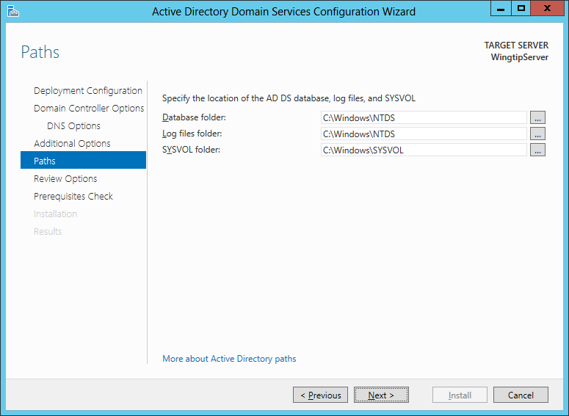

* 1. The **Review Options** page shows the wizard settings you selected. Click **Next** to continue to the next page in the wizard.

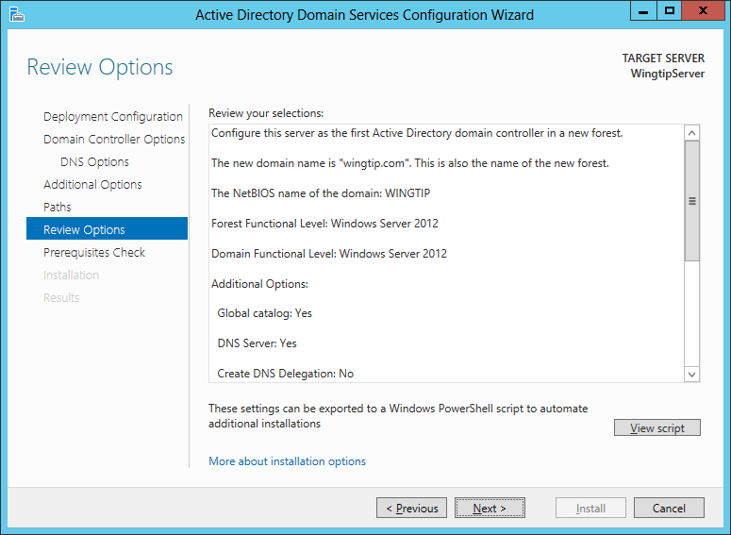

* 1. The last page of the **Active Directory Domain Service Configuration Wizard** is the **Perquisites Check** page. This page will run a test which takes about minute. The purpose of the test is to verify that the **WingtipServer** VM meets the requirements of a domain controller computer.
  2. After the tests completes, click the **Install** button to begin the process of creating the new Active Directory domain and promoting the **WingtipServer** VM to become a new domain controller.

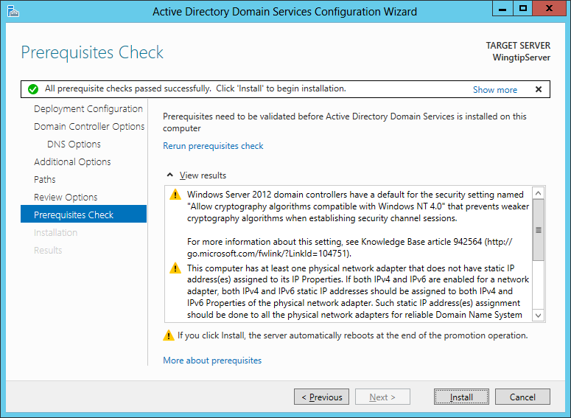

* 1. During the installation process, the **WingtipServer** VM will automatically restart. After the **WingtipServer** VM has restarted, log back in using the domain account **WINGTIP\Administrator**.

1. Use the **Active Directory Users and Computer** administrative tool to inspect the **wingtip.com** domain.
   1. Click on the **Windows** key to display the **Windows Start** page. Now you should see several start items for Active Directory tools. Locate on the tile for the **Active Directory Users and Computer** administrative tool. The tile might only display **Active Directory Users and…** as shown in the following screenshot.

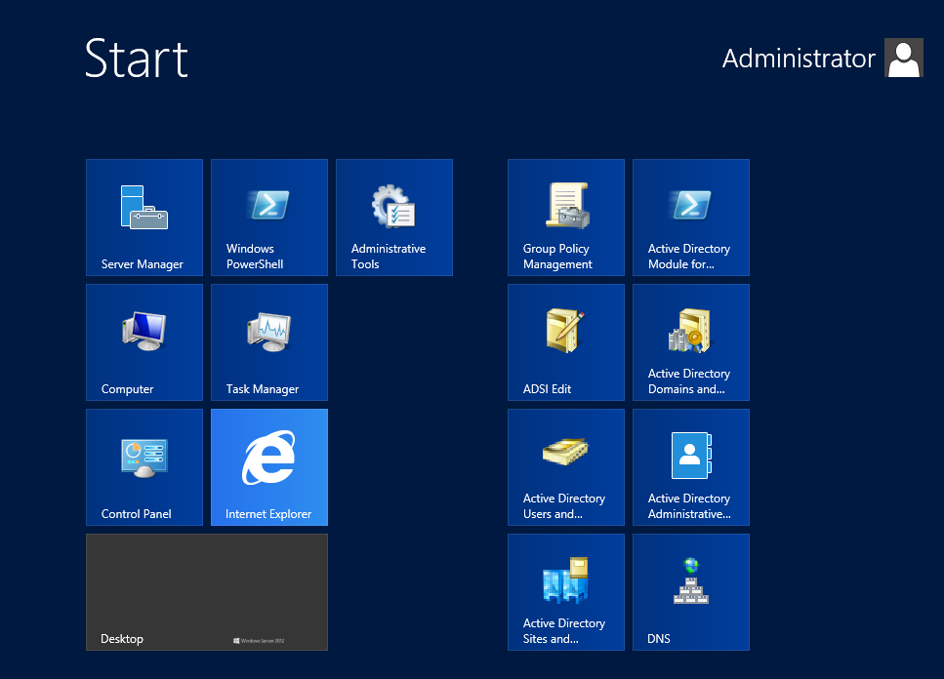

* 1. Click on the tile on the Windows Start page to start the **Active Directory Users and Computer** administrative tool.
     1. When the **Active Directory Users and Computer** administrative tool starts, you should see a node for **wingtip.com**.
     2. Expand the **wingtip.com** node and select the **Users** node inside.
     3. You should be able to see all the user and group accounts that Windows automatically adds to a new domain.

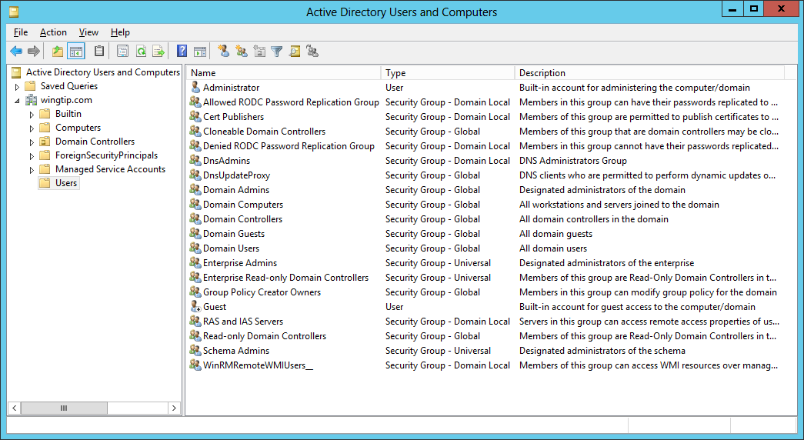

* 1. You have now verified that the **wingtip.com** domain has been properly created and that the **WingtipServer** VM has been promoted to be a domain controller.
  2. Close the **Active Directory Users and Computer** administrative tool.

### Task 6: Install SQL Server Enterprise 2012 with Service Pack 1

You will begin this task by acquiring the installation files and optionally a product key for SQL Server Enterprise 2012. After that you will move through the basic steps of installing SQL Server 2012 and configuring it for basic usage within a SharePoint 2013 farm. After that you will install Service Pack 1 for SQL Server 2012 to ensure that SharePoint Server 2013 can take advantage of additional SQL Server 2012 features.

1. Obtain a copy of the 64-bit installation binaries for SQL Server 2012.
   1. Choose between using your own licensed copy of SQL Server Enterprise 2012 or using the free trial version.  
      Note: if you are given the option download the **SQL Server 2012 Enterprise Edition with Service Pack 1.** This will remove the need to install SP1 separately
   2. If you plan to use a licensed copy, acquire the install image (*.iso) for SQL Server 2012 (with SP1 if possible) and the product key.
   3. If you plan to use a free trial copy of SQL Server 2012, follow these steps:
      1. Navigate to the evaluation down page at **http://www.microsoft.com/en-us/download/details.aspx?id=29066**.
      2. Locate the download named **SQLFULL_ENU.iso** and click the **DOWNLOAD** button to download it to your host computer.

This download is several gigabytes in size so it will take some time to download. The amount of time it takes to download will depend upon the speed of your Internet connection.

1. Navigate to the Hyper-V Manager. Right-click the **WingtipServer** VM and select the **Connect…** command to display the Hyper-V console window for this VM.



1. In this step you will configure the VM to load the .ISO file with the SQL Server 2012 installation files as a DVD drive.
   1. In the Hyper-V console windows for the **WingtipServer** VM, select the **Insert Disk…** command.

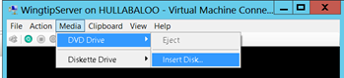

* 1. When the **Open File** dialog appears, enter the path to the .ISO file with the SQL Server 2012 installation files. Click **OK**.

1. Navigate back into the user interface of the **WingtipServer** VM.
2. Depending on your configuration, the SQL Server installation program in the DVD might or might not start automatically.
   1. If the **AutoPlay** dialog box is open, click run **setup.exe**.
   2. If the **AutoPlay** dialog box is not open, use Windows Explorer to navigate to the DVD drive and execute the **setup.exe** file in the root of the DVD drive.
   3. Wait for the SQL Server installation program to initialize and display the **SQL Server Installation Center** dialog.
3. In the **SQL Server Installation Center** dialog, complete the following steps:
   1. Click the **Installation** link on the left-hand side.
   2. Click the **New SQL Server stand-alone installation or add features to an existing installation link** on the right-hand side.

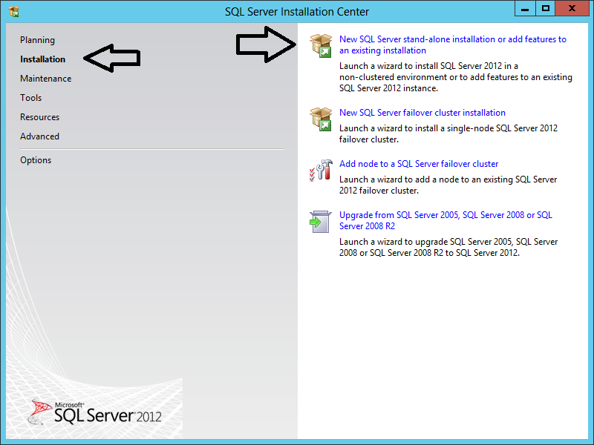

1. On the **Setup Support Rules** page, the installer will check for potential issues before installing.
   1. Verify that the **WingtipServer** VM has passed all the tests.
   2. Click **OK** to move to the next page.

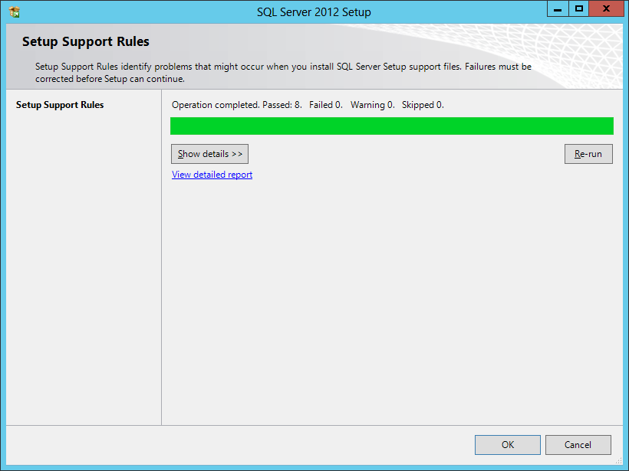

1. What you do on the **Product Key** page depends on whether you are using the free trial or a licensed version of SQL Server 2012.
   1. If you are using the free trial version, click the **Specify a free edition** radio box and select **Evaluation**.
   2. If you are using a licensed version, enter your 25-character product key
   3. Click **Next** to move to the next page.

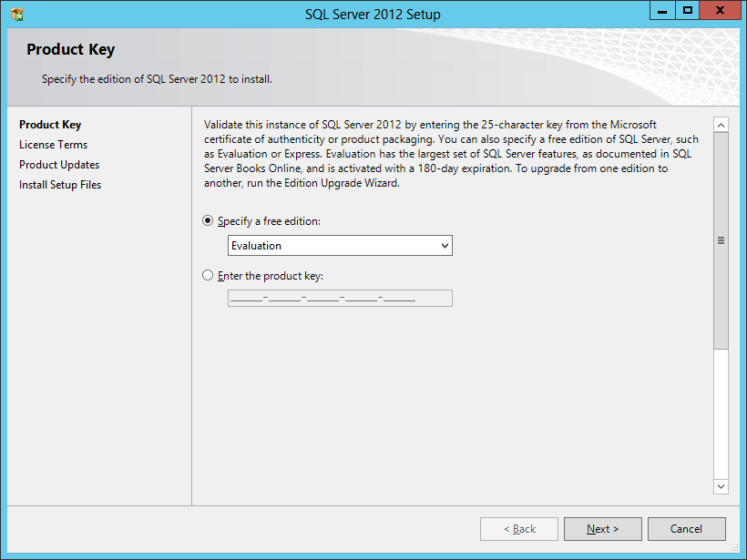

1. On the **License Terms** page, check the option **I accept the license terms** and click **Next**.

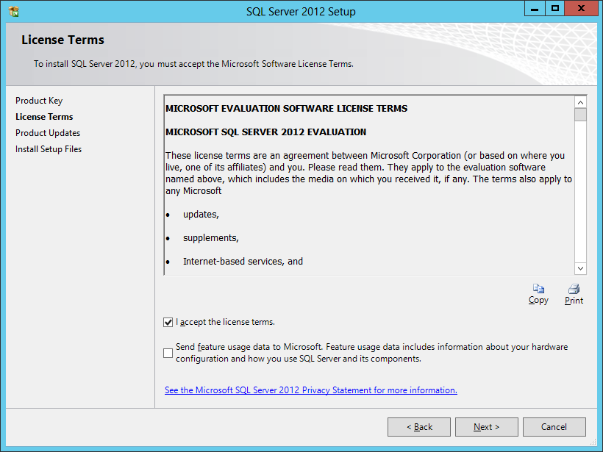

1. On the Product Updates page update any needed items and then click **Next.**  
   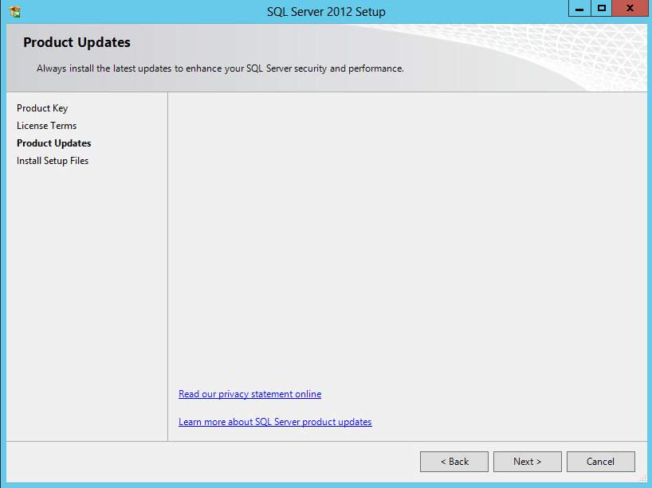
2. The next page is the **Setup Support Rules** page which runs checks on the **WingtipServer** VM to detect if there are any potential problems you might encounter when installing SQL Server 2012.
   1. You should see all the tests were passed except the one that warns that the **WingtipServer** VM is a domain controller.
   2. While you should never install SQL Server on domain controller in a production environment, you can ignore the domain controller warning in a scenario like this when creating a lab environment such as the **WingtipServer** VM.
   3. Note: you might also receive a Microsoft .Net Application Security error related to the computer not being able to access the internet. Should you receive this error, open Internet Explorer (press the **Windows Key** and on the Start Page click on the **Internet Explorer** tile). Using Internet Explorer navigate to a website (e.g. Bing.com). If this site is returned in the browser, you may ignore this warning.
   4. Click **Next** to move to the next page.

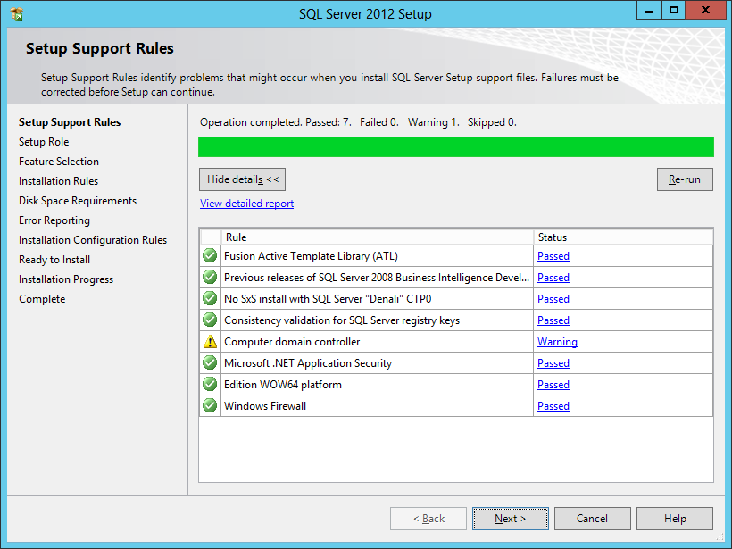

1. On the **Setup Role** page, select **SQL Server Feature Installation** and click **Next**.

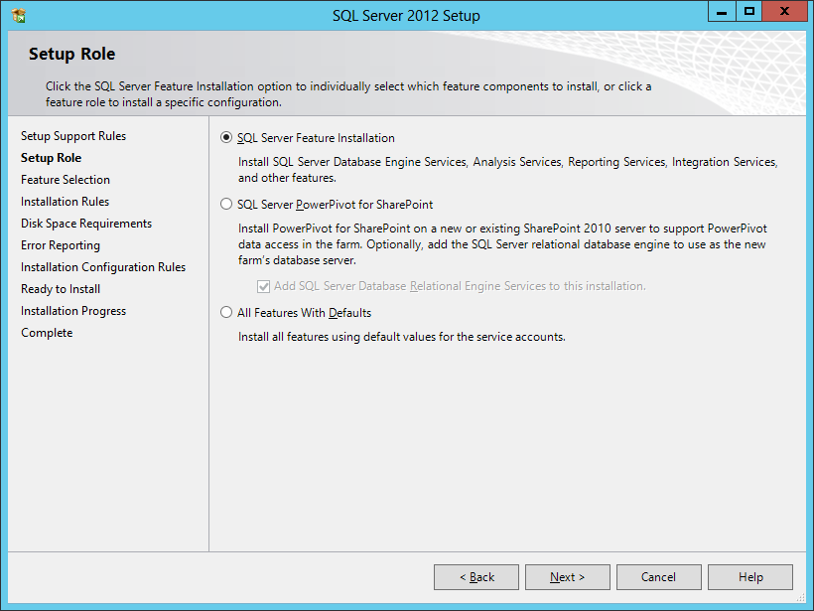

1. On the **Feature Selection** page, check the following options and click **Next**:
   1. Instances Features:
      1. Database Engine Services
      2. Full-Text and Semantic Extractions for Search
      3. Analysis Services
   2. Shared Features:
      1. Reporting Services - SharePoint
      2. Reporting Services Add-in for SharePoint Products
      3. Management Tools – Basic
      4. Management Tools – Complete

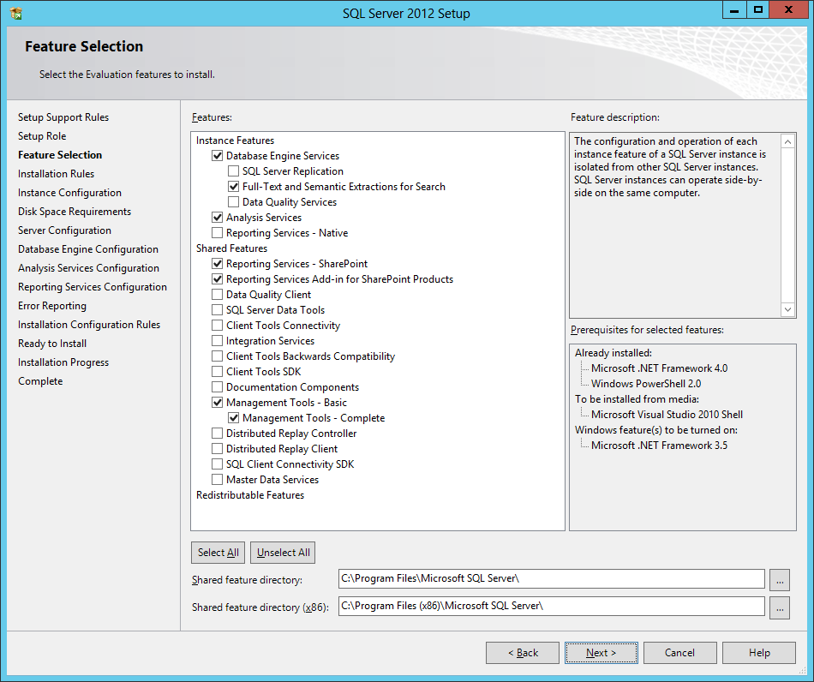

The minimal installation of SQL Server 2012 for SharePoint 2013 only requires the **Database Engine Services**. However, it is recommended that you also install the Management Tools so you have GUI tools to administer SQL Server 2012. The **Full-Text and Semantic Extractions for Search** feature is required if you plan to use **Access Services** in SharePoint Server 2013. Adding in **Analysis Services** and **Reporting Services** is only required when you want to configure and use the Business Intelligence (BI) features of SharePoint Server 2013 while leveraging integration with SQL Server Reporting Services.

1. On the **Installation Rules** page, click **Next**.
2. On the **Instance Configuration** page, accept all the default settings and click **Next**.

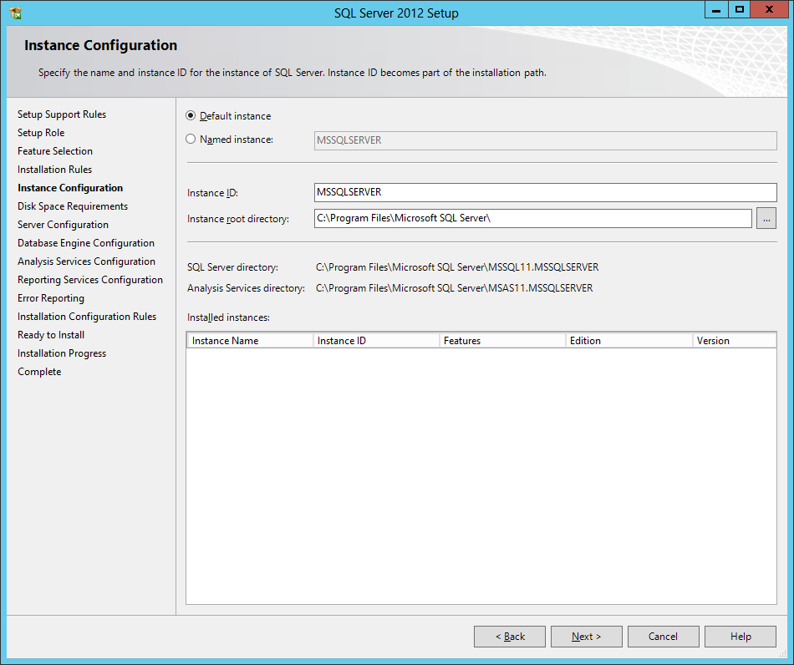

1. On the **Disk Space Requirements** page, click **Next**.
2. On the **Service Account** tab of the **Server Configuration** page, do the following:
   1. Change the **Startup Type** for the **SQL Server Agent** to **Automatic**.
   2. Change the **Account Name** for the **SQL Server Database Engine** to **NT AUTHORITY\SYSTEM**.
   3. Change the **Account Name** for the **SQL Server Analysis Services** to **NT AUTHORITY\SYSTEM**.
   4. Click **Next** to move to the next page.

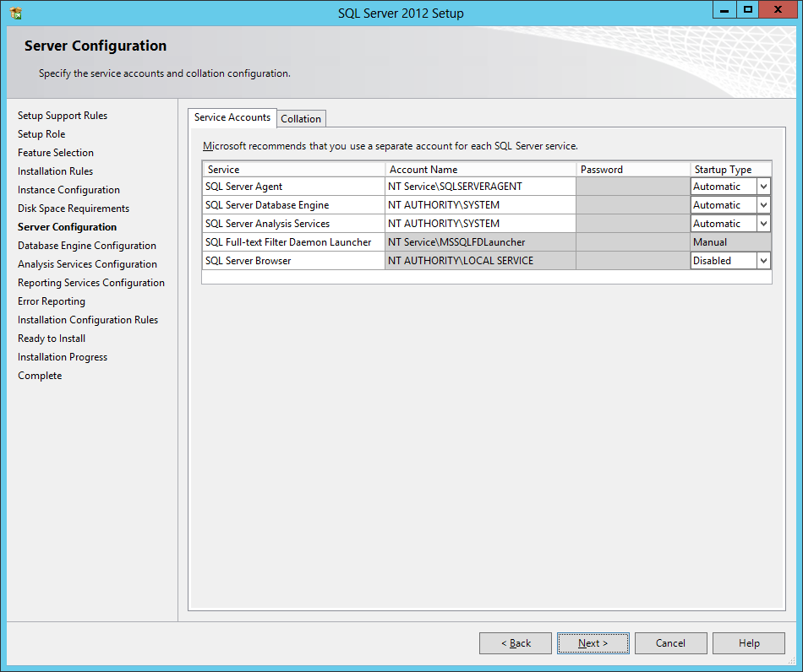

In a real-world installation of SQL Server in a production environment, you should consider using dedicated user accounts to provide the identity for the SQL Server services instead of using the SYSTEM account. This setup guide is using the SYSTEM account for the SQL Server worker processes to simplify the installation of SQL Server which is acceptable in a lab environment.

1. On the **Database Engine Configuration** page, do the following:
   1. On the **Server Configuration** tab, click the **Add Current User** button to configure the **WINGTIP\Administrator** account as a system administrator for this SQL Server instance.

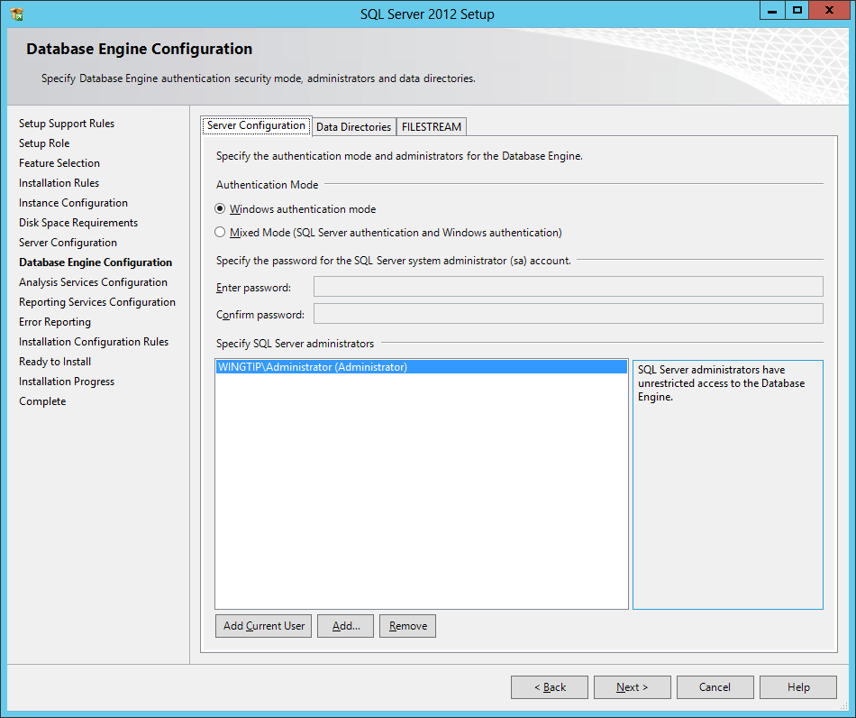

* 1. On the **FILESTREAM** tab, check **Enable FILESTREAM for Transact-SQL access** and also check **Enable FILESTREAM for file I/O access**.

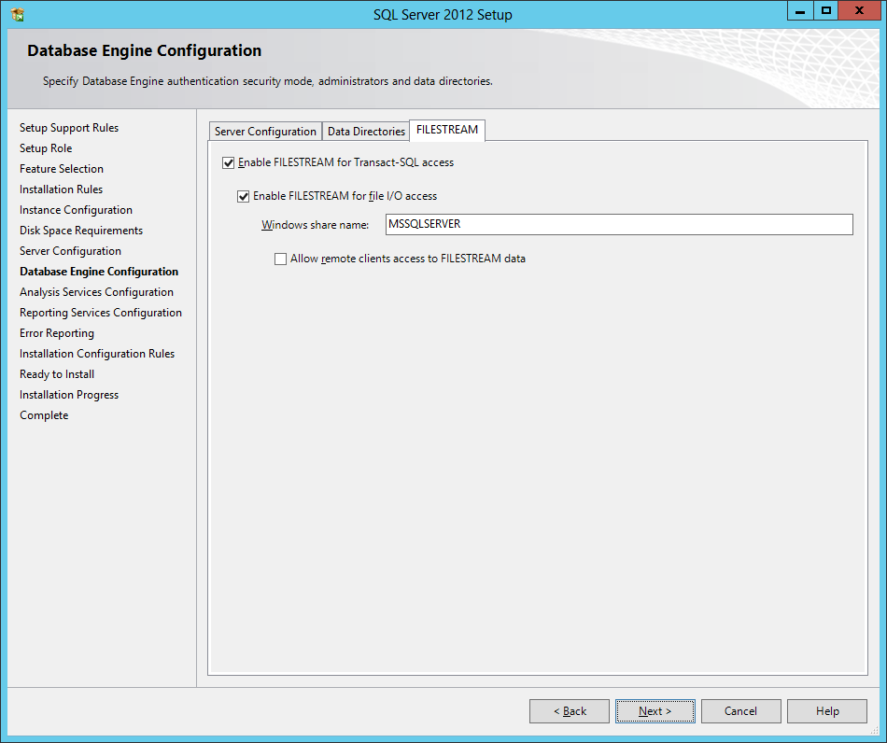

* 1. Click **Next** to move to the next page

1. On the **Server Configuration** tab of the **Analysis Services Configuration** page:
   1. Click **Add Current User** to configure the **WINGTIP\Administrator** account with administrative permissions.
   2. Click **Next** to move ahead to the next page.

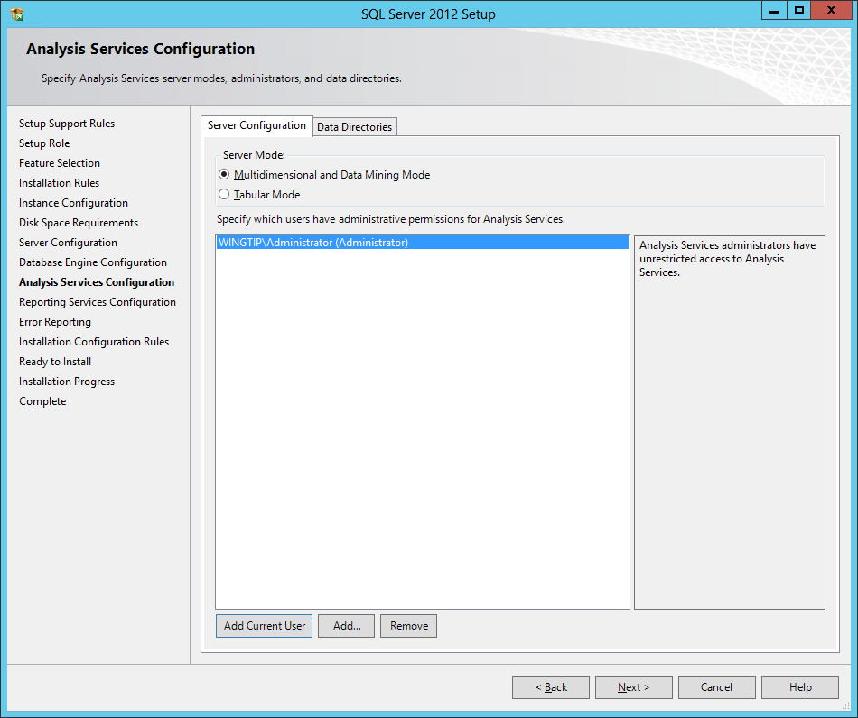

1. On the **Reporting Services Configuration** page, accept the default selection of **Install only** and click **Next** to move ahead.

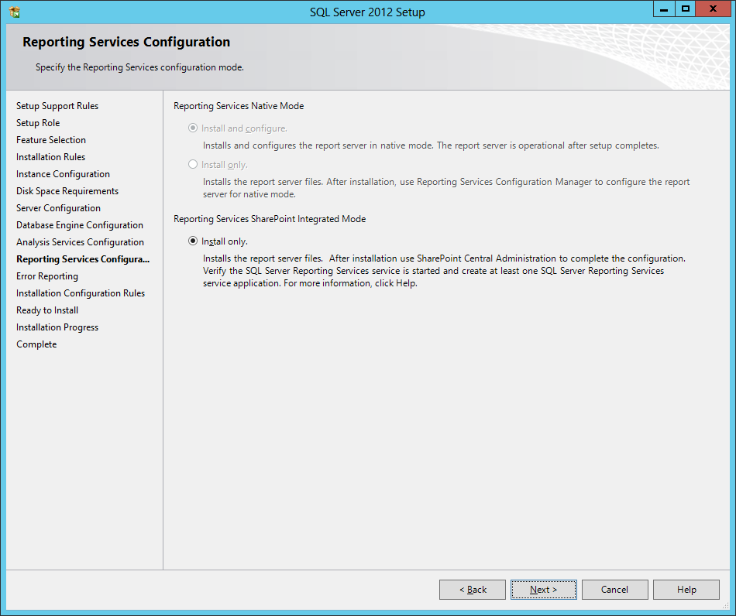

1. On the **Error Reporting** page, accept the default values and click **Next**.
2. On the **Installation Configuration Rules** page, click **Next**.
3. When you get to the **Ready to Install** page, you are finally at the point where you can begin the installation. Click the **Install** button and wait for the SQL Server installation program to complete. This process will likely take about 10-15 minutes to complete.
4. When the installation finishes, the **Complete** page is displayed showing the features that were successfully installed.

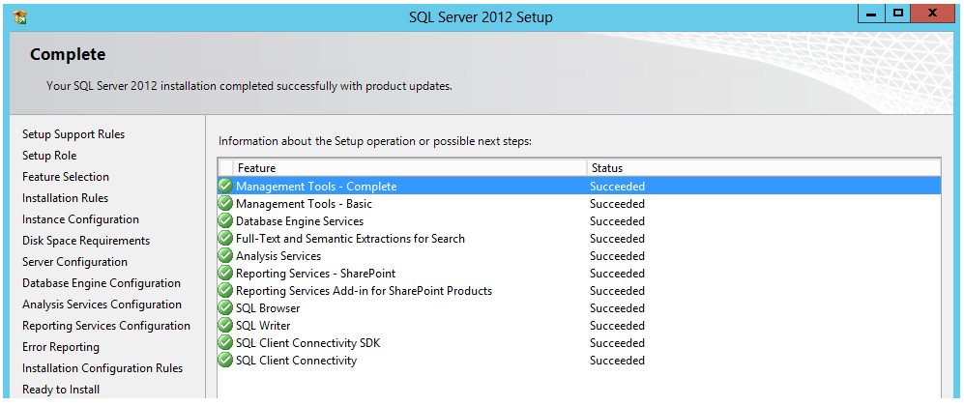

1. Click **Close** to complete the installation.

You have now successfully installed SQL Server 2012. The next step (if you did not use a download with SP 1 included) is to download and install Service Pack 1.  
Note: **if you have already installed SQL Server 2012 with SP1 included you may skip ahead to step 28.**

1. Download **Service Pack 1** for **SQL Server 2012**.
   1. Make sure you are logged onto the **WingtipServer** VM as **WINGTIP\Administrator**.
   2. Browse to the download page at **http://www.microsoft.com/en-us/download/details.aspx?id=35575**
   3. Download the 64-bit installation file for service pack 1 named **SQLServer2012SP1-KB2674319-x64-ENU.exe**.

This download is 929 MB. The time it takes to complete will vary significantly depending on the bandwidth of your Internet connection.

1. Install **Service Pack 1** for **SQL Server 2012**.
   1. Using the Windows Explorer, locate the installation file named **SQLServer2012SP1-KB2674319-x64-ENU.exe**. Right click this EXE file and select **Run as Administrator**.

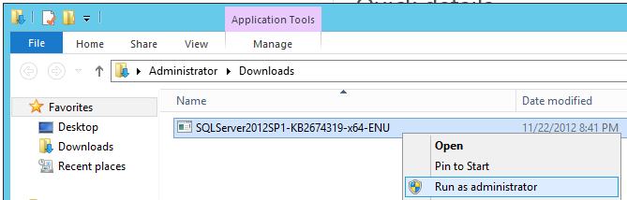

* 1. As the installation program for service pack 1 begins, it will display the following dialog while it initializes.

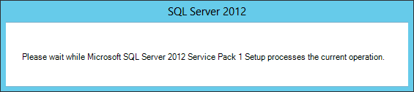

* 1. When you are prompted with the **SQL Server 2012 update** page, click **Next** to continue.

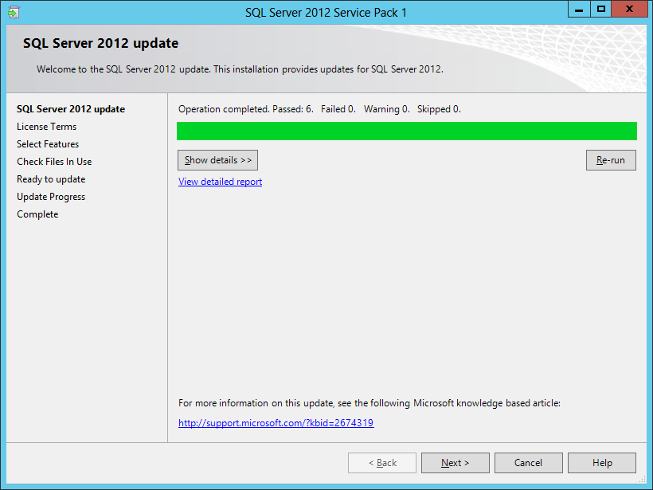

* 1. On the **License Terms** page, check **I accept the license terms** and click **OK**.

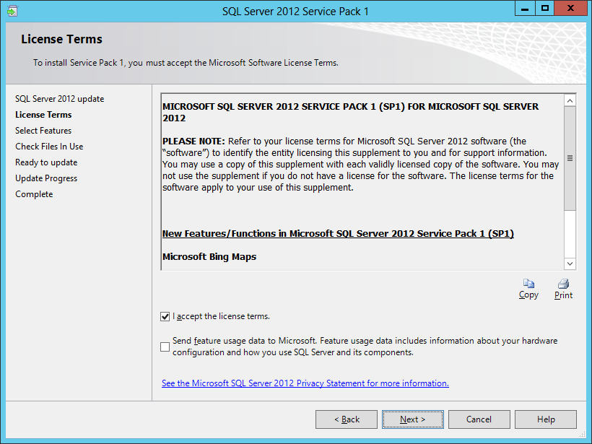

* 1. On the **Select Features** page, accept the default values and click **Next** to continue.

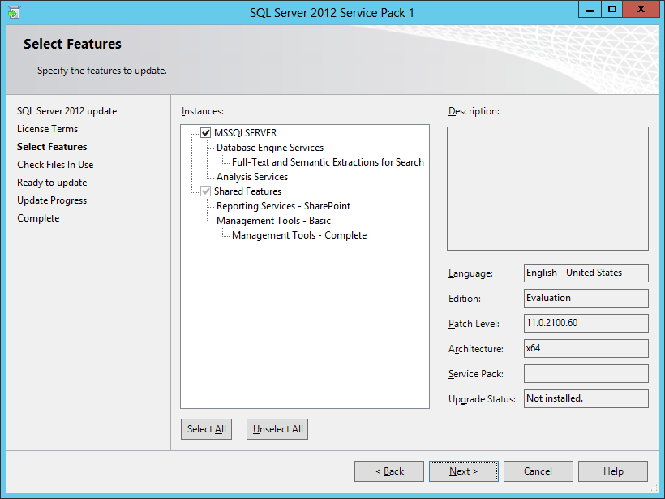

* 1. In the **Check Files In Use** page, click **Next** to continue.

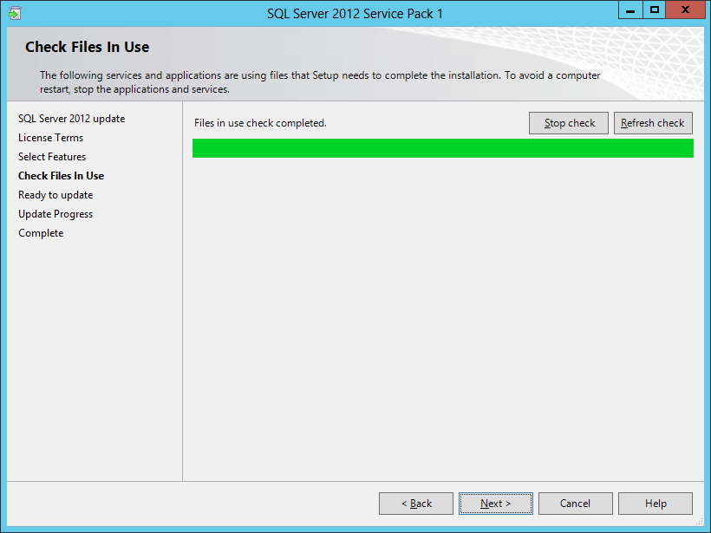

* 1. On the **Ready to update** page, click the **Update** button to begin the installation of service pack 1**.**

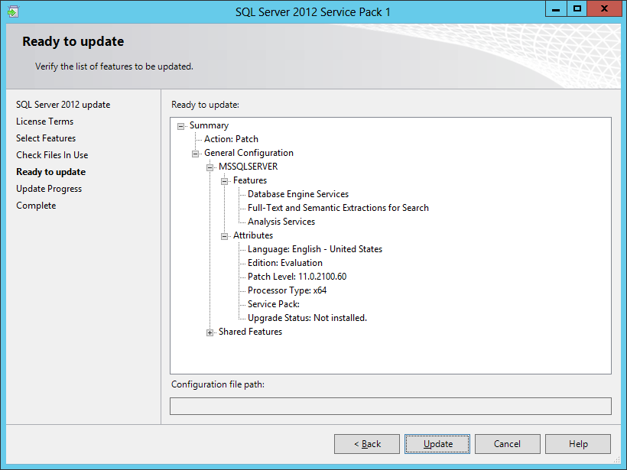

* 1. When the installation of service pack 1 is complete, you are prompted with the **Complete** page. Click **Close** to close the dialog and complete the installation process of service pack 1.

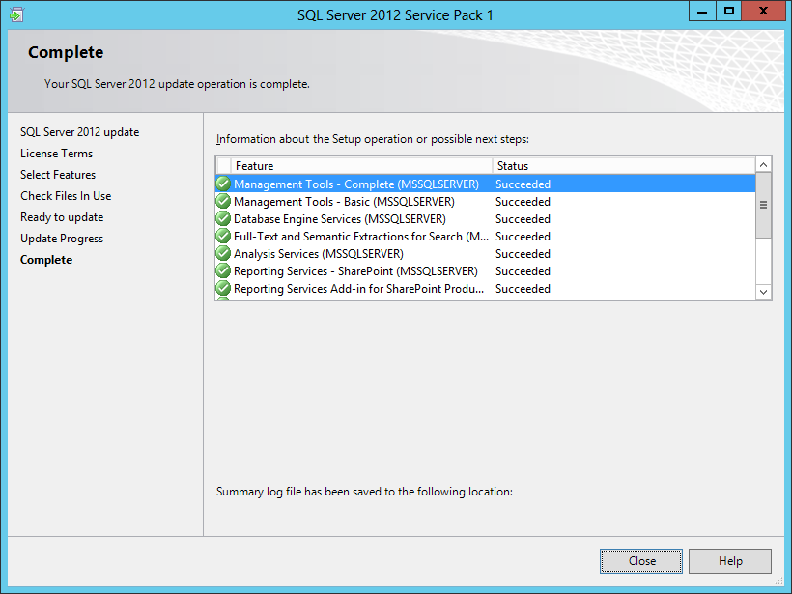

1. Configure the **Named Pipes** protocol using the **SQL Server Configuration Manager**.
   1. Press the **Windows** key to navigate to the Windows Start page.
   2. Locate and click the **SQL Server Configuration** tile to launch the **SQL Server Configuration Manager**.

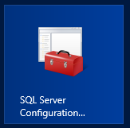

* 1. In the SQL Server Configuration Manager, expand the nodes of the tree view control on the left to the following path.
     1. **SQL Server Configuration Manager** >> **SQL Server Network Configuration** >> **Protocols for MSSQLSERVER**.  
        Note: Make certain to expand **SQL Server Network Configuration** and NOT **SQL Server Network Configuration (32bit).**
     2. On the right-had side, locate the property setting for the **Named Pipes** protocol. This protocol is initially in a disabled state.
     3. Right click on the **Named Pipes** property and select the **Enabled** command.

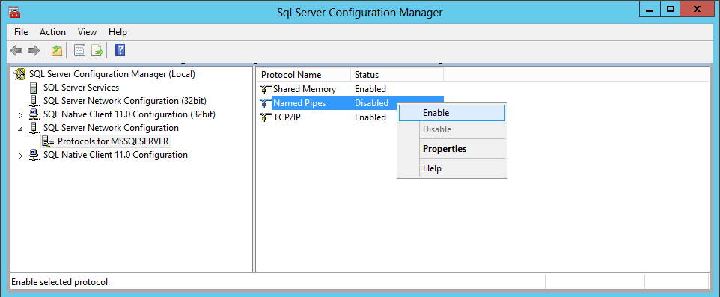

* + 1. Verify that all three protocols are in an enabled state.

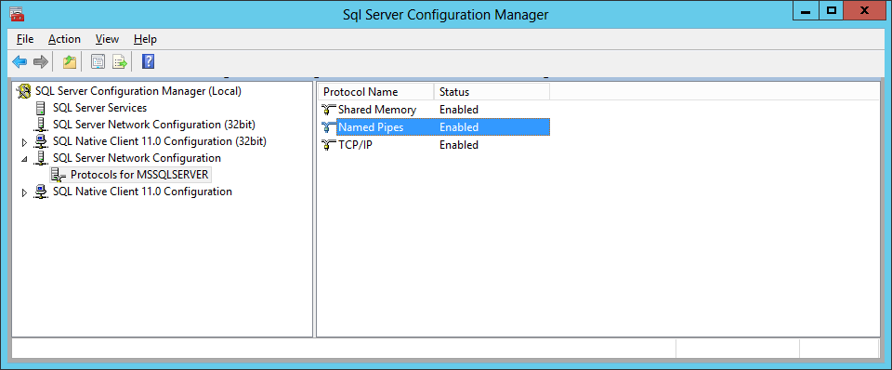

* 1. Close the **SQL Server Configuration Manager**.

1. Connect the **SQL Server Database Engine** using **SQL Server Management Studio**.
   1. Press the **Windows** key to navigate to the Windows Start page.
   2. Locate and click the **SQL Server Management Studio** tile to launch **SQL Server Management Studio**.

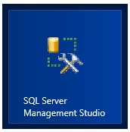

* 1. When you are prompted with the **Connect to Server** dialog, ensure it is filled out as the screenshot below. Click the **Connect** button to connect to the Database Engine where you will be able to see the existing set of databases.

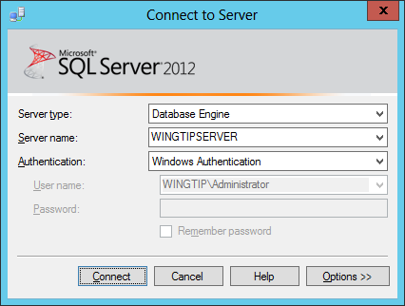

* 1. Once **SQL Server Management Studio** has connected to the **SQL Server Database Engine**, you should see the **Object Explorer** with a tree view control with **WINGTIPSERVER** as its top-level node.
     1. Expand the **Databases** node and then the **System Databases** node.
     2. You should be able to see the system database such as **master** and **tempdb**.
     3. However, there are no user-created databases yet.

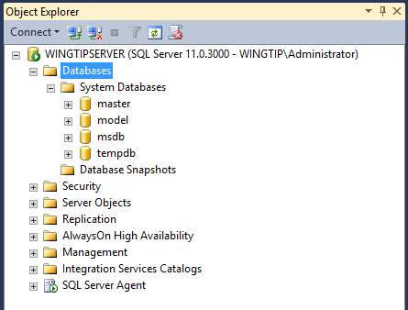

1. Connect to **SQL Server Analysis** in the **SQL Server Management Studio**.
   1. Drop down the **Connect** menu in the **Object Explorer** and select the **Analysis Services…** command.

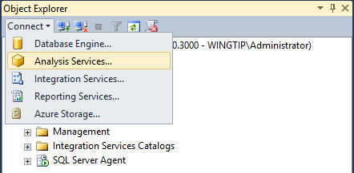

* 1. When you are prompted with the **Connect to Server** dialog, ensure it is filled out as the screenshot below. Click the **Connect** button to connect to **Analysis Services**.

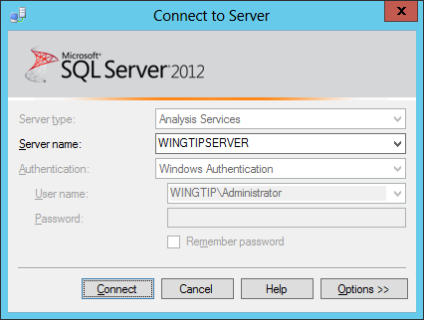

* 1. When you connect to Analysis Services, you will find there are no Analysis Services databases because this is a default installation. However, the **WingtipServer** VM is now prepared to support SQL Server Analysis Services databases if you decide to add them.

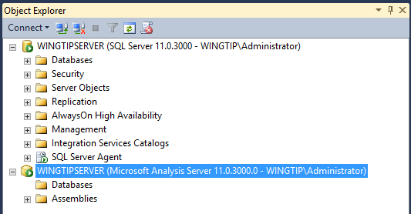

* 1. Close **SQL Server Management Studio**.

You have now successfully installed SQL Server 2012 and applied Service Pack 1. You are now finished installing and configuring software in the **WingtipServer** VM. In the final task, you will download installation files for SharePoint Server 2013 and SharePoint Designer 2013 so these installation files are available on the local hard drive of the **WingtipServer** VM for when it's time to install them during the lab exercises of the course.

### ****Task 7: Download the Installation Files Required to install SharePoint Server 2013****

In this task you will download the installation files for **SharePoint Server 2013** and **SharePoint Designer 2013** and make them available on the local hard drive of the **WingtipServer** VM.

1. Create a new directory named **Install** on the **C:\** drive of the **WingtipServer** VM.
   1. Once created, the path to this directory should be **c:\Install**
2. Download the installation files for the trial edition of SharePoint Server 2013.
   1. Go to the SharePoint Server 2013 trial download page at **http://technet.microsoft.com/en-us/evalcenter/hh973397**.
   2. Read the instructions on the page and go through the process of registering for the trial version.
   3. Download the installation file named **SharePointServer_x64_en-us.img** to the **c:\Install** directory.
3. Extract the SharePoint Server 2013 installation files from **SharePointServer_x64_en-us.img**.
   1. Use the Windows Explorer to navigate to the **c:\Install** directory.
   2. Create a new child directory named **SharePointServer2013** at **c:\Install\SharePointServer2013**.
   3. Locate the file named **SharePointServer_x64_en-us.img** in the **c:\Install** directory.
   4. Right-click **SharePointServer_x64_en-us.img** and select the **Mount** command to access the files inside the IMG file in a new window.

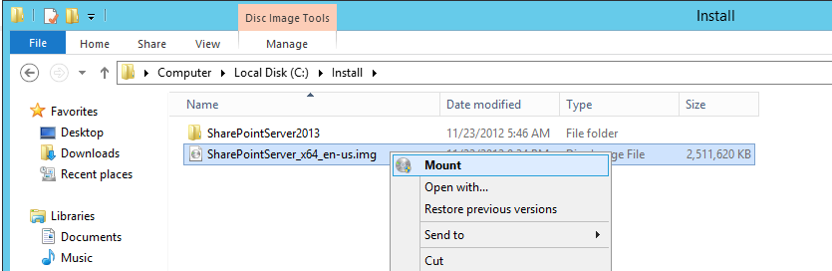

* 1. Look in the new windows and examine the files and folders inside. You should see quite a few folders and files including the main setup program named **setup.exe**.

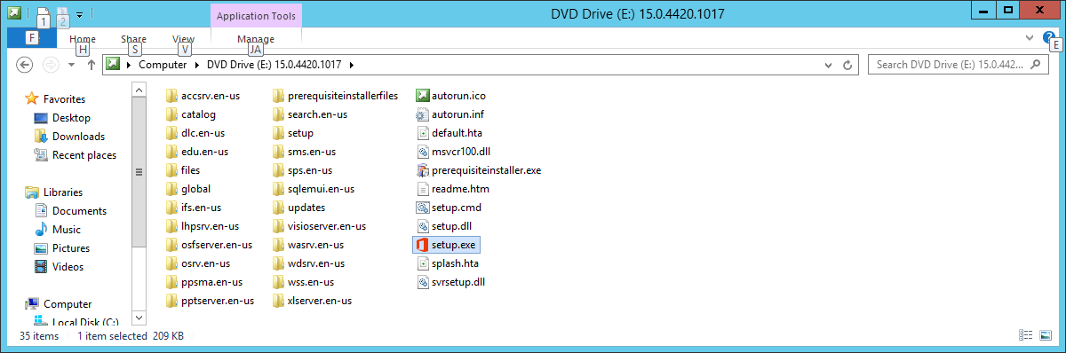

* 1. Copy all the files and folders from the IMG file to the directory at **c:\Install\SharePoint2013**. When you are done, the **C:\Install\SharePointServer2013** directory on the **WingtipServer** VM should look like the one below.

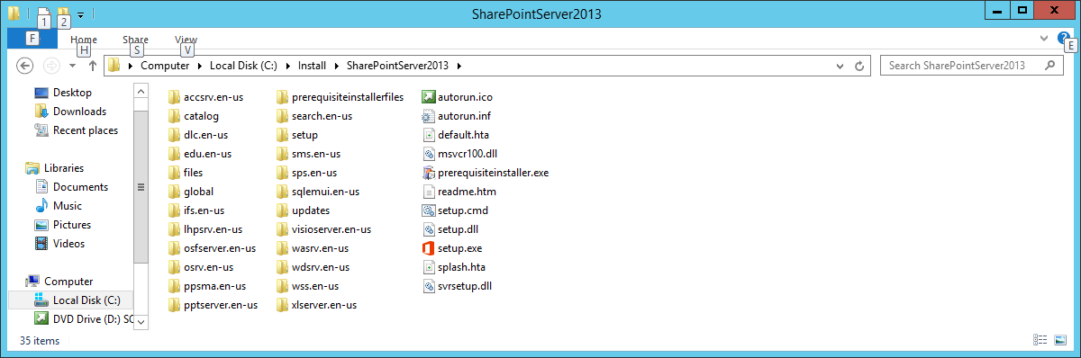

1. Download the installation files for **SharePoint Designer 2013**.
   1. Go to the SharePoint Designer 2013 download page at **http://www.microsoft.com/en-us/download/details.aspx?id=35491**.
   2. On the download page, locate the installation file for the 64-bit edition named **sharepointdesigner_64bit.exe**.
   3. Download the installation file to the **WingtipServer** VM at the path **c:\Install\** **sharepointdesigner_64bit.exe**.

At this point you have downloaded the installation files for SharePoint Server 2013 and SharePoint Designer 2013 and made them available on the local hard drive of the WingtipServer VM.

### **Task 8: Install the SharePoint Server 2013 Prerequisites**

In this task you will run the Install to prepare the Wingtip Server for SharePoint. You will not, however, run the Configuration Wizard as we will do this in class.

1. Navigate to the directory with the installation files at **C:\Install\SharePointServer2013**. Locate the file named **PrerequisiteInstaller.exe**. Now double-click this file to run Prerequisite Installer**.**

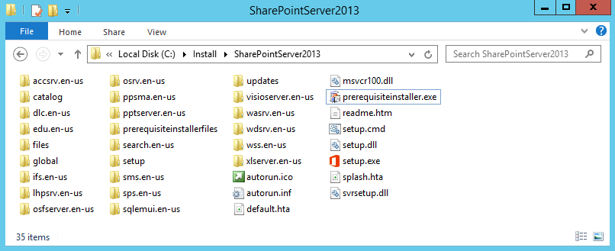

1. Click **Next** at the welcome screen.

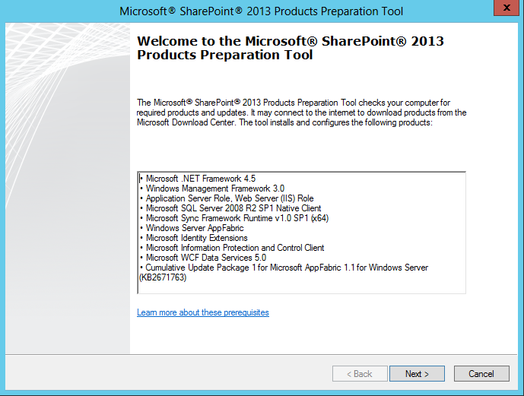

1. On the next screen, click the **check box** which states you agree to the licensing terms and then click **Next** to begin installing the SharePoint Server 2013 prerequisites. Note the perquisite installer ensures that the following software is already installed.
   1. .NET Framework version 4.5
   2. Windows Management Framework 3.0

Keep in mind that the Prerequisite Installer requires an Internet connection to work properly. If your VM does not have an active connection to the Internet, the Prerequisite Installer will fail with errors.

1. The Prerequisite Installer will enable the **Application Server Role** for **WingtipServer** and then prompt you to restart the VM. Reboot the VM. When prompted, click **Finish** so the Prerequisite Installer can reboot the **WingtipServer** server in order to continue installing the perquisites for SharePoint Server 2013.

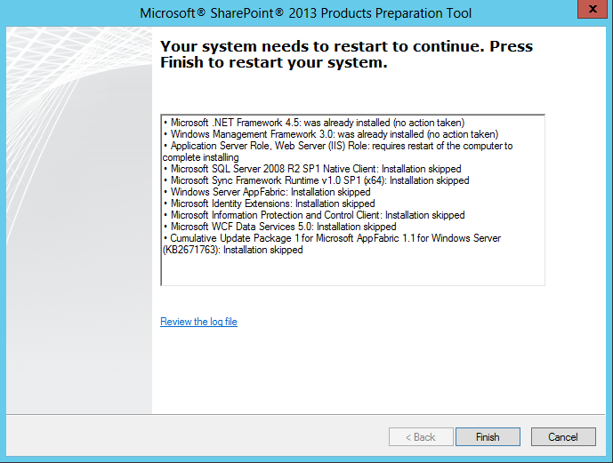

1. When the **WingtipServer** server has rebooted, log on as **WINGTIP\Administrator** with a password of **Password1**. You should notice that the Perquisite Installer will automatically resume and continue its work.

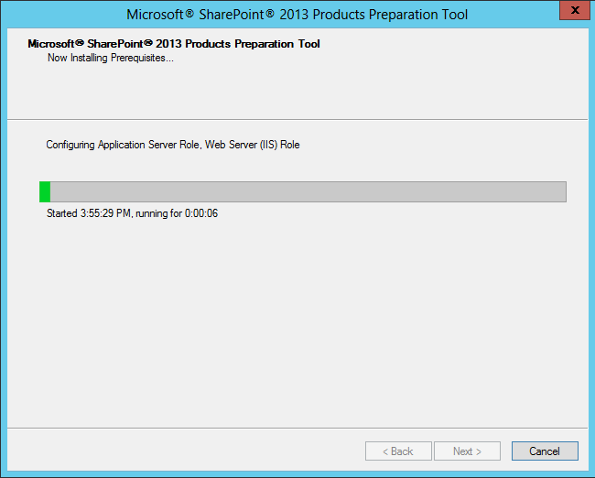

1. After the reboot, the prerequisite installer will install and configure the following components
   1. Application Server Role, Web Server (IIS) Role
   2. Windows Identity Foundation (KB974405)
   3. Microsoft Sync Framework Runtime v 1.0 SP1
   4. Windows Server App Fabric
   5. Microsoft Identity Extensions
   6. Microsoft Information Protection and Control Client
   7. Microsoft WCF Data Services 5.0
   8. Cumulative Update Package1 for Microsoft App Fabric 1.1 for Windows Server (KB2671763)
2. After the Prerequisite Installer configures these components (mentioned in step 6) for **WingtipServer**, it will prompt you to restart the VM. Reboot the VM. When prompted, click **Finish** so the Prerequisite Installer can reboot the **WingtipServer** server in order to continue installing the perquisites for SharePoint Server 2013.

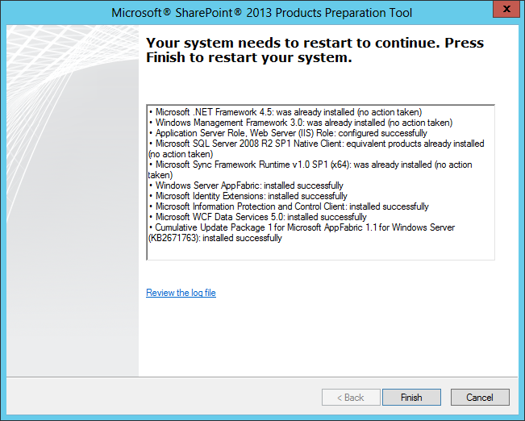

1. When the **WingtipServer** server has rebooted, log on as **WINGTIP\Administrator** with a password of **Password1**. You should notice that the Perquisite Installer will automatically resume and continue its work.

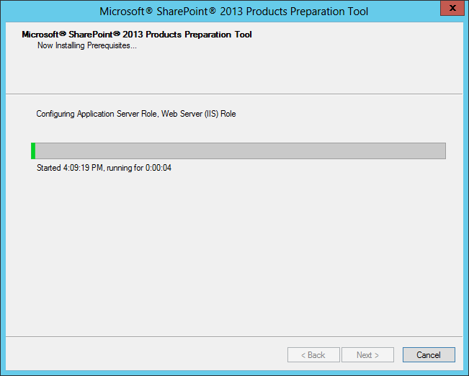

1. When the Prerequisite Installer completes, it will display an **Installation Complete** dialog with a summary of everything it did. Review what has been installed.

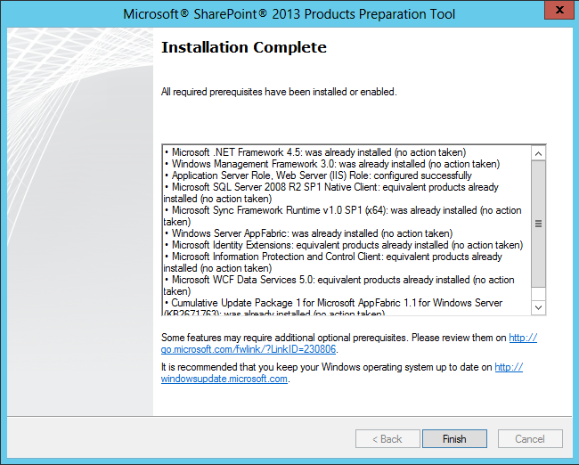

1. Click **Finish**.

At this point all prerequisites required by SharePoint Server 2013 have been installed and any necessary configuration changes have been applied to the server.

### Task 9: Install SharePoint Server 2013

In this section you will install SharePoint Server 2013. This is the final setup task necessary for the SharePoint 2013 Administration courses.

1. Ensure you are logged into the **WingtipServer** VM using the account **WINGTIP\Administrator | Password1**.
2. Navigate to the directory at **C:\Install\SharePointServer2013**. Locate the file named **setup.exe**. Now double-click this file to run the installation program for SharePoint Server 2013.

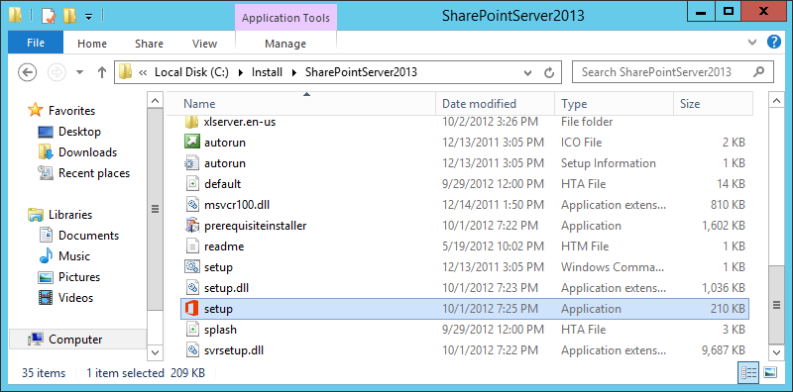

1. When prompted to **Enter your Product Key**, enter the trial key of **NQTMW-K63MQ-39G6H-B2CH9-FRDWJ** tocontinue with the installation of the **Microsoft SharePoint Server 2013**. Click **Continue**.

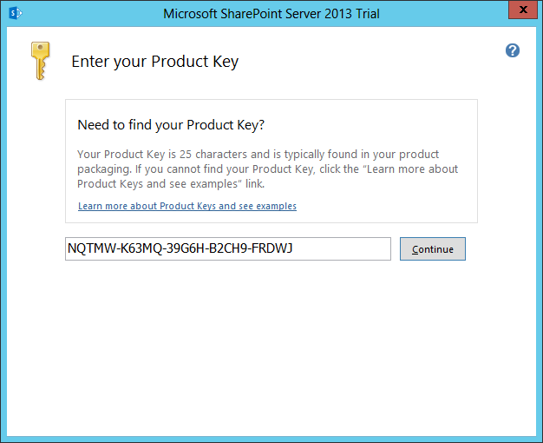

1. On the **Read the Microsoft Software License Terms** page, check the **I accept the terms of this agreement** checkbox and click **Continue**.

When you install SharePoint Server 2013 on a server computer that is not a domain controller, the SharePoint 2013 installation program displays the **Server Type** page which prompts you to select between an installation type of **Complete** or **Stand-alone**. You should always choose the **Complete** installation on any production server. Since you are installing SharePoint Server 2013 on a domain controller, the SharePoint 2013 installation program automatically selects the **Complete** installation type and does not display the Server Type page.

1. On the **Choose a file location** page, accept the default settings and click **Install Now**.

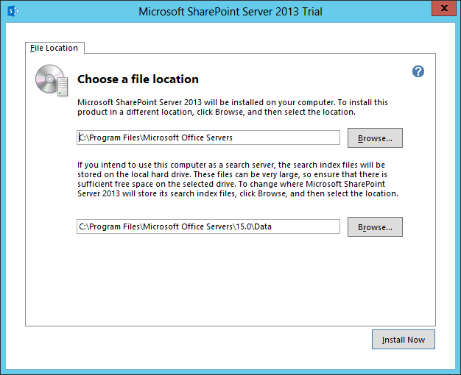

1. When the SharePoint Server 2013 installation program completes, it displays the **Run Configuration Wizard** page as shown in the following screenshot. Ensure the **Run the SharePoint Products Configuration Wizard** checkbox is **NOT** selected and click **Close**.  
   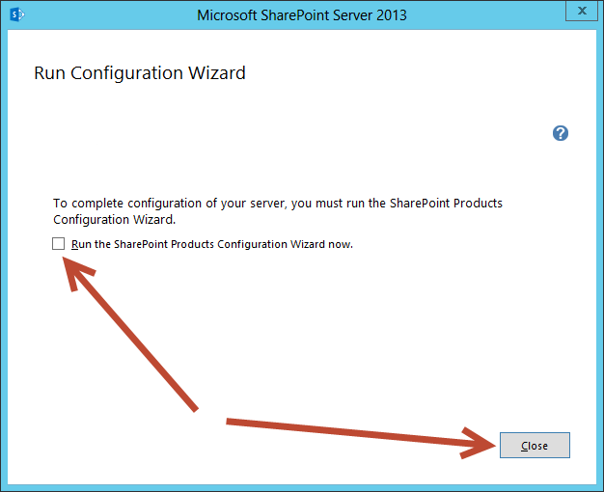

You have now completed building the VM that can be used as the starting point to complete the lab exercises for the SharePoint 2013 IT Pro courses offered by Critical Path Training. You may now shut down the VM in preparation for the course start.   
To shut down the VM press **Windows Key + I** and then on the Settings window select the **Power** button.  
(Note: it is always a good idea to take a backup of this VM Image just in case you would like to try something again after you begin the course)